
A
PROJECT REPORT
ON
SPATIAL MODELING OF SOLAR RADIATION USING GEOSTATISTICAL ANALYTIC MODELS OVER WEST AFRICA
A Comparative Study of Six Interpolation Methods for Surface Incoming Shortwave Radiation across West Africa
WRITTEN BY
AFOLAMI BRIGHT JAMES
PHY/18/8232
SUBMITTED TO
THE DEPARTMENT OF PHYSICS
SCHOOL OF PHYSICAL SCIENCES
THE FEDERAL UNIVERSITY OF TECHNOLOGY AKURE, ONDO STATE.
IN PARTIAL FULFILLMENT OF THE REQUIREMENTS FOR THE AWARD OF
BACHELOR OF TECHNOLOGY (B. TECH) DEGREE IN PHYSICS (ELECTRONICS).
2024

CERTIFICATION
I, Afolami Bright with matric number PHY/18/8232 hereby certify that this work was entirely done by me with the guidance of my supervisor and that no part of this project work has been submitted for any other academic qualification or assessment. I take responsibility for acts of commission or omission found in this work. Any external sources used in this project work have been duly cited and referenced following the appropriate citation style.

______________________________ ______________________________
AFOLAMI BRIGHT JAMES DATE
(STUDENT)

______________________________ ______________________________
DR. OLUSOLA SAMUEL OJO DATE
(SUPERVISOR)

DEDICATION
I dedicate this project work to God Almighty and to my family for their unwavering support, encouragement, and guidance throughout my studies.

ACKNOWLEDGEMENTS
First and foremost, I thank God for his divine wisdom, strength and inspiration which enabled me to complete this project.

I extend my heartfelt appreciation to my parents, Mr. Afolami Oluwapelumi and Mrs. Afolami Odunola for their unwavering support, encouragement and love. I’m also grateful to my uncle, Afolami Oluwayomi, my aunt, Adebowale Omowumi, my siblings and friends for their constant care and motivation that kept me going.

Special thanks to my supervisor, Dr. Olusola Samuel Ojo for their invaluable guidance and patience throughout the course of this study. I would also like to thank both the teaching and non-teaching staff of the Department of Physics for providing the academic environment and resources necessary for this study.

This project would not have been possible without the collective efforts and support of these individuals; I am forever grateful.

ABSTRACT

Accurate spatial estimation of solar radiation is essential for solar energy planning, agricultural applications, and climate studies in data-sparse regions such as West Africa. This study aimed to model the spatial distribution of Surface Incoming Shortwave (SIS) radiation across West Africa using six geostatistical and deterministic interpolation methods, such as Inverse Distance Weighting (IDW), Ordinary Kriging (OK), Empirical Bayesian Kriging (EBK), Radial Basis Function (RBF), Local Polynomial Interpolation (LPI), and Global Polynomial Interpolation (GPI). Monthly mean SIS data from 108 meteorological stations spanning the period 1983–2023 were obtained from the archive of the CM-SAF dataset at a resolution of 0.05° × 0.05° latitude and longitude, on a grid system over West Africa. Spatial interpolation was performed in ArcGIS Geostatistical Analyst, and the accuracy of each method was assessed through leave-one-out cross-validation. Results showed that interpolation accuracy was both metric- and month-dependent rather than following a uniform dry-season versus rainy-season pattern. RBF produced the lowest mean RMSE (2.91 Wh/m²) and MAE across the monthly tables, followed by EBK (3.20 Wh/m²), Ordinary Kriging (3.49 Wh/m²), and IDW (3.99 Wh/m²). EBK achieved the highest mean R² (0.948) and the lowest mean MedAE, while Ordinary Kriging produced the smallest absolute average mean error and also provided model-based uncertainty estimates. Regression slopes for Ordinary Kriging and EBK ranged from approximately 0.49 to 0.88, indicating compression of observed SIS variability. GPI and LPI produced the largest overall errors among the six methods. RBF, EBK, Ordinary Kriging, and IDW each achieved their lowest monthly RMSE in different months, confirming that no single method dominated across all evaluation conditions. These findings indicate that method choice for solar radiation mapping should be guided by the specific accuracy metric of interest rather than a single “best” interpolator. Accordingly, solar-resource assessments and planning frameworks in West Africa should favor RBF- or EBK-based interpolation, with Ordinary Kriging recommended where quantified prediction uncertainty is required for decision-making.

TABLE OF CONTENTS
TITLE PAGE i
CERTIFICATION ii
DEDICATION iii
ACKNOWLEDGEMENTS iv
ABSTRACT v
TABLE OF CONTENTS vi
LIST OF TABLES viii
LIST OF FIGURES ix
CHAPTER ONE: INTRODUCTION 1
1.1 Background of the Study 1
1.2 Problem Statement 2
1.3 Aim and Objectives 3
1.4 Significance of the Study 3
CHAPTER TWO: LITERATURE REVIEW 5
2.1 Solar Radiation: Concepts and Measurement 5
2.2 Previous Studies on Solar Radiation Interpolation 7
2.3 Research Gap 10
CHAPTER THREE: METHODOLOGY 11
3.1 Study Area 11
3.2 Data Acquisition 12
3.3 Spatial Interpolation Methods 13
3.4 Theoretical Framework for Spatial Analysis 15
3.5 Interpolation Methods Used in This Study 17
3.6 Assessment of Interpolation Methods 22
CHAPTER FOUR: RESULTS AND DISCUSSION 24
4.1 Monthly Spatial comparison of Solar Radiation from Geostatistical methods 24
4.2 Cross-Validation Results 36
4.3 Detailed Monthly Analysis 39
4.4 Comparative Analysis of Methods 45
4.5 Comparison with Previous Studies 47
4.6 Summary of Results 48
CHAPTER FIVE: CONCLUSION AND RECOMMENDATIONS 49
5.1 Conclusion 49
5.2 Recommendations 51
REFERENCES 54
APPENDICES 57
Appendix A: List of Meteorological Stations 57
Appendix B: Cross-Validation Regression Equations 61

LIST OF TABLES
Table 3.1: Comparison of interpolation method characteristics 15
Table 4.1: Cross-validation accuracy metrics averaged across all 12 months 36
Table 4.2: Cross-validation regression parameters for Kriging, EBK and RBF 38
Table 4.3: Cross-validation regression parameters for IDW, GPI and LPI 38
Table 4.4: Cross-validation metrics for January 39
Table 4.5: Cross-validation metrics for February 40
Table 4.6: Cross-validation metrics for March 40
Table 4.7: Cross-validation metrics for April 41
Table 4.8: Cross-validation metrics for May 41
Table 4.9: Cross-validation metrics for June 42
Table 4.10: Cross-validation metrics for July 42
Table 4.11: Cross-validation metrics for August 43
Table 4.12: Cross-validation metrics for September 43
Table 4.13: Cross-validation metrics for October 44
Table 4.14: Cross-validation metrics for November 44
Table 4.15: Cross-validation metrics for December 45

LIST OF FIGURES
Figure 3.1: Study area showing the distribution of 108 meteorological stations across West Africa and the four climatic zones. 13
Figure 4.1: January SIS interpolation showing all six methods side by side 25
Figure 4.2: February SIS interpolation showing all six methods side by side 26
Figure 4.3: March SIS interpolation showing all six methods side by side 27
Figure 4.4: April SIS interpolation showing all six methods side by side 28
Figure 4.5: May SIS interpolation showing all six methods side by side 29
Figure 4.6: June SIS interpolation showing all six methods side by side 30
Figure 4.7: July SIS interpolation showing all six methods side by side 31
Figure 4.8: August SIS interpolation showing all six methods side by side 32
Figure 4.9: September SIS interpolation showing all six methods side by side 33
Figure 4.10: October SIS interpolation showing all six methods side by side 34
Figure 4.11: November SIS interpolation showing all six methods side by side 35
Figure 4.12: December SIS interpolation showing all six methods side by side 36

CHAPTER ONE

INTRODUCTION

1.1 Background of the Study
Solar radiation is a fundamental energy input to the Earth's surface and is central to weather and climate processes, photosynthesis, the hydrological cycle, and the surface energy balance. Reliable measurement and estimation of solar radiation are therefore important for applications such as solar-energy system design, agricultural planning, hydrological modeling, and climate studies (Duffie and Beckman, 2013).
Surface Incoming Shortwave radiation (SIS), commonly expressed in solar-energy applications as global horizontal irradiance (GHI), is the total shortwave solar radiation incident on a horizontal surface. It contains a direct component from the solar disk and a diffuse component produced by scattering in the atmosphere; on a horizontal surface, GHI is commonly represented as the sum of the projected direct normal irradiance and diffuse horizontal irradiance (Duffie and Beckman, 2013).
Solar radiation varies spatially because solar geometry, topography, cloudiness, aerosols, water vapor, and other atmospheric conditions differ from place to place. This spatial variability creates a practical need for location-specific radiation estimates when designing solar-energy systems or producing regional resource maps. Geostatistical studies have shown that spatial interpolation can be used to extend discrete radiation observations into continuous regional fields when station coverage is incomplete (Rehman and Ghori, 2000; Alsamamra et al., 2009).
West Africa spans strong climatic gradients from the humid Gulf of Guinea coast through the savanna and Sahel to the Saharan margin. Cloud cover and atmospheric conditions change substantially between the wet and dry seasons, producing marked spatial and seasonal contrasts in surface solar radiation. Studies in Ghana and in Burkina Faso/Ghana confirm pronounced seasonal differences and show that cloud conditions materially affect the quality of solar-radiation estimates (Tanu et al., 2021; Sawadogo et al., 2023).
Ground-based solar-radiation observations remain limited across many parts of West Africa, which makes spatially complete regional assessment difficult. Recent validation work in Burkina Faso and Ghana notes the scarcity of accessible in-situ GHI observations and evaluates satellite and reanalysis products as practical alternatives where station measurements are unavailable (Sawadogo et al., 2023). This measurement scarcity strengthens the case for carefully validated spatial interpolation and satellite-based products.
Spatial interpolation estimates values at unsampled locations from observations at known locations. Geostatistical methods such as Kriging explicitly model spatial dependence and can provide prediction-uncertainty estimates, while Empirical Bayes Kriging extends automated geostatistical modeling by accounting for uncertainty in semivariogram estimation and allowing local adaptation where appropriate (Webster and Oliver, 2007; Krivoruchko and Gribov, 2019).

1.2 Problem Statement
The accurate spatial estimation of solar radiation across a region requires interpolation from discrete point measurements to a continuous surface. Traditional interpolation methods, such as simple arithmetic averaging or Thiessen polygons, do not account for the spatial correlation structure inherent in meteorological data and often produce unreliable estimates, particularly in areas distant from measurement stations.
Geostatistical methods offer a more rigorous framework for spatial interpolation by explicitly modeling the spatial dependence structure of the data through the variogram function. Techniques such as Kriging, Empirical Bayes Kriging (EBK), and their variants provide not only predictions at unsampled locations but also measures of prediction uncertainty, which are invaluable for decision-making (Webster and Oliver, 2007). However, the selection of the most appropriate geostatistical method for a given application and region is not straightforward.
Different methods make different assumptions about the stationarity of the mean and variance, the form of the spatial correlation function, and the noise characteristics of the data. The performance of these methods can vary significantly depending on the density and configuration of the sampling network, the nature of the spatial variability, and the specific characteristics of the variable being estimated (Chilès and Delfiner, 2012). For solar radiation in West Africa, several unique challenges arise:
Lack of comprehensive comparative studies: While individual studies have applied specific methods to specific regions, there is a lack of systematic comparative evaluations of multiple geostatistical methods for solar radiation across the full diversity of West African climates.
There is therefore a need for a systematic comparative evaluation of geostatistical interpolation methods for solar radiation in the West African context, using cross-validation techniques to assess prediction accuracy and identify the most suitable approach for operational applications.

1.3 Aim and Objectives
Aim:
The aim of this study is to develop spatial models for the accurate prediction of solar radiation across West Africa using geostatistical analytic techniques.
Objectives:
The specific objectives of this study are to:
1. Examine spatial distribution of solar radiation over West Africa.
2. Evaluate the spatial interpolation of solar radiation over West Africa using Geospatial analytic models and
3. Assess the accuracy of the Geospatial interpolation models using statistical metrics.

1.4 Significance of the Study
This study contributes to the growing body of knowledge on spatial modeling of solar radiation in data-sparse regions. The findings are expected to be beneficial in several ways:
1. Solar Energy Planning: The spatial models developed in this study can be used to identify optimal locations for solar energy installations across West Africa, supporting the region's transition to renewable energy sources. Accurate SIS maps are essential for solar resource assessments, which inform decisions about panel orientation, system sizing, and expected energy yield.
2. Agricultural Applications: Accurate solar radiation maps are essential for crop modeling, evapotranspiration estimation, and irrigation planning, all of which are critical for food security in the region. Solar radiation is a key input to crop growth models, and spatial interpolation of SIS can improve the accuracy of agricultural productivity estimates across data-sparse areas.
3. Climate Studies: The long-term spatial radiation fields produced by this study can serve as inputs for regional climate models and for monitoring changes in solar radiation over time. The 41-year record analyzed in this study provides a baseline against which future changes in solar radiation can be assessed.
4. Methodological Contribution: The comparative evaluation of multiple geostatistical and deterministic methods provides guidance for selecting interpolation techniques for solar radiation in similar climatic settings. The results show that method ranking depends on the accuracy metric and month, while the inclusion of EBK alongside Ordinary Kriging and deterministic alternatives broadens the methodological comparison.

CHAPTER TWO

LITERATURE REVIEW

2.1 Solar Radiation: Concepts and Measurement
a. Solar radiation reaching the Earth's surface consists of several components. The global horizontal irradiance (GHI), also referred to as Surface Incoming Shortwave (SIS) radiation, is the total solar radiation received on a horizontal surface. It is the sum of the direct normal irradiance (DNI), which is the solar radiation received directly from the solar disk, and the diffuse horizontal irradiance (DHI), which is the solar radiation received from the sky after being scattered by the atmosphere (Duffie and Beckman, 2013):
 | $$GHI=DNI·cosθ+DHI$$ | (2.1)

where θ is the solar zenith angle.
The magnitude of solar radiation at a given location is controlled by solar geometry and Earth-Sun distance, together with atmospheric attenuation by clouds, aerosols, water vapor, and ozone. These controls determine how much of the extraterrestrial solar flux reaches the surface and how it is divided between direct and diffuse components (Duffie and Beckman, 2013).
Clear-sky radiation is the irradiance expected in the absence of clouds, subject to attenuation by the clear atmosphere. Well-established clear-sky formulations include the Ineichen-Perez approach and the European Solar Radiation Atlas (ESRA) model, both of which account for atmospheric optical effects when estimating surface irradiance (Ineichen and Perez, 2002; Rigollier et al., 2000).
Clouds are a dominant source of short-timescale variability in surface solar radiation because they alter both direct and diffuse irradiance through scattering and absorption. Their optical thickness, type, and fractional coverage can therefore introduce strong spatial and temporal changes in satellite-derived and ground-observed irradiance fields (Pinker and Laszlo, 1992).
Aerosols are also important in West Africa, particularly during dust events associated with Saharan transport. Their effect interacts with cloud cover and other atmospheric conditions, which complicates solar-radiation retrieval and validation. A recent West African evaluation found that the performance of satellite and reanalysis GHI estimates deteriorated under cloudy conditions and explicitly considered both cloud and aerosol effects (Sawadogo et al., 2023).
b. Ground-based solar radiation is commonly measured with pyranometers for global horizontal irradiance and pyrheliometers for direct normal irradiance. Reliable observations require appropriate instrument siting, calibration, maintenance, and quality-control procedures in accordance with accepted meteorological practice (WMO, 2014).
Measurement uncertainty depends on instrument characteristics and operating conditions, including calibration quality, cosine response, spectral response, thermal effects, cleanliness, leveling, and obstruction of the sensor field of view. These factors must be controlled when observations from different stations or instruments are combined.
The Baseline Surface Radiation Network (BSRN) was established to provide high-quality surface-radiation observations using standardized measurement and quality-control procedures (Ohmura et al., 1998). Such reference-quality measurements are especially valuable for validating satellite-derived products and for detecting systematic biases in regions where routine station coverage is sparse.
Data quality considerations are critical for solar radiation studies. Common data quality issues include:
1. Instrument degradation: Pyranometer sensitivity can change over time due to aging, dirt accumulation, and exposure to extreme conditions. Regular calibration against reference instruments is essential.
2. Shadowing: Nearby objects (buildings, trees, terrain) can cast shadows on the pyranometer, causing systematic underestimation of solar radiation, particularly during morning and evening hours.
3. Power failures and data gaps: Many meteorological stations in developing countries experience frequent power interruptions, leading to gaps in the record.
4. Systematic biases: Different pyranometer types and measurement protocols can introduce systematic biases that must be accounted for when combining data from multiple stations.
c. Satellite-based methods estimate surface solar radiation from satellite-observed cloud information together with clear-sky radiative-transfer calculations and atmospheric inputs. Several long-term products are relevant to solar-resource assessment over Africa:
1. CM SAF SARAH: The Surface Radiation Data Set - Heliosat (SARAH) is derived from Meteosat observations and provides surface incoming shortwave radiation and related variables over Europe and Africa. SARAH-2.1 covers 1983-2017 at 0.05° spatial resolution, while the current SARAH-3 record begins in 1983 and is operationally extended to the present (Pfeifroth et al., 2019; Pfeifroth et al., 2023).
2. CAMS solar radiation products: The Copernicus Atmosphere Monitoring Service provides solar-radiation time series from 2004 onward and is widely used for solar-energy applications. In West Africa, CAMS has been evaluated alongside SARAH-2, ERA5, and MERRA-2 using quality-controlled in-situ observations (Sawadogo et al., 2023).
3. CERES: The Clouds and the Earth's Radiant Energy System (CERES) provides satellite observations of the Earth's radiation budget and has become an important source for climate-scale radiation studies (Wielicki et al., 1996).
4. Satellite products provide far better spatial coverage than sparse station networks, but their accuracy depends on cloud detection, aerosol representation, atmospheric inputs, and retrieval algorithms. They should therefore be evaluated against quality-controlled ground measurements whenever possible.
For West Africa, Sawadogo et al. (2023) found that satellite products generally performed better than reanalysis products in their 2020 validation dataset, while errors increased substantially under cloudy skies. This finding reinforces the need to treat satellite radiation fields as estimates with quantifiable uncertainty rather than as error-free observations.

2.2 Previous Studies on Solar Radiation Interpolation
Global Studies
Published studies show that no interpolation method is uniformly best across all solar-radiation datasets; performance depends on station density, spatial structure, topography, covariates, and the validation design.
Rehman and Ghori (2000) applied geostatistical interpolation to global solar radiation in Saudi Arabia using 41 known locations and systematic point exclusion for validation. Their results demonstrated that geostatistical interpolation can provide accurate regional estimates when the spatial structure is adequately represented.
Alsamamra et al. (2009) compared Ordinary Kriging with residual Kriging for monthly global solar radiation in southern Spain using 166 stations, including an independent validation set. Ordinary Kriging gave useful estimates, while incorporating topographic explanatory information through residual Kriging reduced RMSE by about 5-20% depending on season.
Jeong et al. (2017) compared nearest-neighbor, IDW, and Ordinary Kriging interpolation with artificial-neural-network models at 13 stations in southern Quebec. Geostatistical interpolation performed better where measurement density was high, whereas stochastic models became more competitive where nearby radiation observations were sparse.
Kuo et al. (2018) compared IDW and Ordinary Kriging using 20 monitoring stations in Taiwan and independent field verification. In that application, IDW outperformed Ordinary Kriging, with field-verification MAPE values of 4.30% and 3.71%, illustrating that Kriging should not be assumed to dominate every dataset.
Leirvik and Yuan (2021) compared Random Forest with seven conventional spatial-interpolation methods for global surface solar-radiation observations. Their cross-validation results showed a substantially lower mean absolute error for the Random Forest model, highlighting the potential value of machine-learning methods when suitable predictors are available.
Together, these studies show that interpolation accuracy is strongly context-dependent. Proper validation is therefore more defensible than selecting a method solely because it has performed well in another region.

African Studies
Mubiru et al. (2007) evaluated five interpolation methods for solar radiation in Uganda: Nearest Point, Moving Average, Moving Surface, Trend Surface, and Ordinary Kriging. The Moving Average linear-decrease method performed best in that study, with normalized mean bias error of 0.035 and normalized RMSE of 0.078.
Hove et al. (2014) developed an improved solar-radiation map for Zimbabwe by merging sparse ground observations with satellite-derived information and interpolating with Ordinary Kriging. Leave-one-out validation produced a maximum normalized RMSE of about 0.028, demonstrating the value of combining complementary data sources.
Tanu et al. (2021) evaluated solar-energy resource indicators at 22 synoptic stations across Ghana's climatic zones and used Ordinary Kriging to map stationary values. The study found higher solar radiation in the dry period and lower values in the wet period, emphasizing the importance of seasonal cloud and humidity conditions.
Sawadogo et al. (2023) compared ERA5, MERRA-2, CAMS, and SARAH-2 hourly GHI with 37 quality-controlled in-situ measurements in Burkina Faso and Ghana. Satellite products generally outperformed reanalysis products, but both groups showed larger errors under cloudy skies, demonstrating the difficulty of representing short-scale atmospheric variability in West Africa.
The African evidence therefore supports spatial interpolation and satellite products as useful tools in data-sparse environments, while also showing that performance depends on local station density, atmospheric conditions, and the information incorporated into the model.

Methodological Studies
Krivoruchko (2012) introduced Empirical Bayesian Kriging as an automated geostatistical approach for ArcGIS, while Krivoruchko and Gribov (2019) later evaluated the method through simulation experiments and real environmental datasets.
Oliver and Webster (2014) provided a practical tutorial on computing and modeling variograms and emphasized that reliable Kriging depends on defensible variogram estimation and model selection.
Chiles and Delfiner (2012) provide an authoritative treatment of geostatistical theory, including stationarity, Kriging variants, spatial uncertainty, and non-stationary methods.
Webster and Oliver (2007) provide a practical guide to geostatistical methods for environmental scientists, covering sampling, variogram modeling, Kriging, and validation.
Cressie (1993) presents foundational theory for spatial statistics and geostatistics, including covariance models and spatial prediction.
Goovaerts (1997) provides a comprehensive treatment of geostatistics for natural-resource evaluation, including Kriging variants and spatial uncertainty.
Wackernagel (2003) presents multivariate geostatistical methods, including co-Kriging and approaches for incorporating auxiliary variables.

2.3 Research Gap
While the existing literature demonstrates the applicability of geostatistical methods for solar radiation estimation, several gaps remain:
1. Limited full-region comparisons: The studies reviewed above are primarily country-level or subregional applications. Within this reviewed literature, no study evaluates this exact six-method set (IDW, Ordinary Kriging, EBK, RBF, LPI, and GPI) over the full multi-country West African domain used in this project.
2. EBK in this application: EBK has been evaluated for several environmental variables, but its use for regional solar-radiation interpolation in tropical West Africa is less represented in the literature reviewed here.
3. Long-term climatological comparison: There is value in evaluating interpolation methods on a multi-decadal monthly climatology because seasonal spatial structure can differ substantially between dry and wet periods.
4. Reproducible comparison: A consistent cross-validation framework is needed so that the six methods are compared on the same station network and with the same accuracy metrics.
This study addresses these needs by comparing six interpolation methods, including EBK, for monthly SIS across the defined West African study domain using ArcGIS-based cross-validation and presenting the results through comparative maps and statistical accuracy metrics.

CHAPTER THREE

METHODOLOGY

3.1 Study Area
Geographic Coverage
The study area covers West Africa and adjacent regions, extending approximately from latitude 4°N to 27°N and from longitude 18°W to 16°E. This vast region encompasses approximately 6.5 million square kilometers and includes a diverse range of climatic zones, from the hyper-arid Sahara Desert in the north through the semi-arid Sahel belt, the sub-humid Sudan and Guinea savanna zones, to the humid tropical forests along the Gulf of Guinea coast.
The study area includes all or portions of the following countries: Mauritania, Mali, Niger, Chad, Senegal, The Gambia, Guinea-Bissau, Guinea, Sierra Leone, Liberia, Côte d'Ivoire, Burkina Faso, Ghana, Togo, Benin, Nigeria, and parts of Cameroon.
Climatic Zones
The study area spans four major climatic zones:
Saharan Zone (north of 20°N): Extremely arid with annual rainfall below 100 mm. Clear skies dominate, resulting in high solar radiation throughout the year, typically exceeding 6.5 kWh/m²/day. Dust aerosols from the Sahara can significantly attenuate incoming radiation during the Harmattan season (December–February).
Sahel Zone (12°N–20°N): Semi-arid with annual rainfall of 200–600 mm concentrated in the rainy season (June–September). Solar radiation is high during the dry season (November–March) but is reduced during the brief rainy season by increased cloud cover. This zone experiences the largest seasonal variation in solar radiation, with monthly mean SIS ranging from approximately 4,500 Wh/m² during the rainy season to over 6,500 Wh/m² during the dry season.
Guinea Savanna Zone (6°N–12°N): Sub-humid with annual rainfall of 600–1,200 mm, with a longer rainy season (April–October) than the Sahel. Solar radiation is moderate, with monthly mean SIS typically ranging from 3,500 to 5,500 Wh/m².
Coastal/Humid Zone (south of 6°N): Humid with annual rainfall exceeding 1,200 mm. Persistent cloud cover and high humidity reduce solar radiation, particularly during the rainy season. Annual average SIS is typically in the range of 4.0–5.5 kWh/m²/day, the lowest in the study area.

Topography and Land Cover
The study area exhibits significant topographic variation, from sea level along the coast to over 2,000 m in the Fouta Djallon highlands of Guinea and the Adamawa Plateau of Cameroon. The Jos Plateau in central Nigeria (elevation 1,200–1,400 m) represents a notable topographic feature that influences local solar radiation patterns.
Land cover ranges from dense tropical forests in the south, through savanna woodlands and grasslands, to sparse desert vegetation in the north. These land cover differences affect surface albedo and evapotranspiration, which in turn influence local atmospheric conditions and solar radiation.
Significance for Solar Energy
West Africa has substantial but spatially variable solar-energy resources. Observational and interpolation studies in Ghana and wider West Africa show that radiation conditions differ markedly by climatic zone and season, particularly as cloud cover changes between wet and dry periods (Tanu et al., 2021; Sawadogo et al., 2023). These contrasts make spatially resolved solar-radiation mapping important for resource assessment.
Nigeria, the most populous country in the region, has an installed electricity generation capacity of approximately 13,000 MW, but experiences chronic power shortages due to insufficient generation and transmission infrastructure. Solar energy has been identified as a key pathway for addressing this deficit, with the Nigerian government setting a target of 30% renewable energy by 2030.

3.2 Data Acquisition
Solar Radiation Data
The primary data used in this study consist of monthly mean Surface Incoming Shortwave (SIS) values at 108 station locations distributed across West Africa. The working project dataset spans 1983-2023. The SIS data were obtained from the archive of the CM-SAF Satellite Application Facility on Climate Monitoring, derived from Meteosat observations at a spatial resolution of 0.05° × 0.05° over West Africa (Pfeifroth et al., 2019; Pfeifroth et al., 2023).
The dataset provides a 41-year record of monthly SIS values in Wh/m². Each record contains a station index, year, month, and SIS value. Approximately 54,144 station-month records are possible from 108 stations × 41 years × 12 months.
Study Area Map
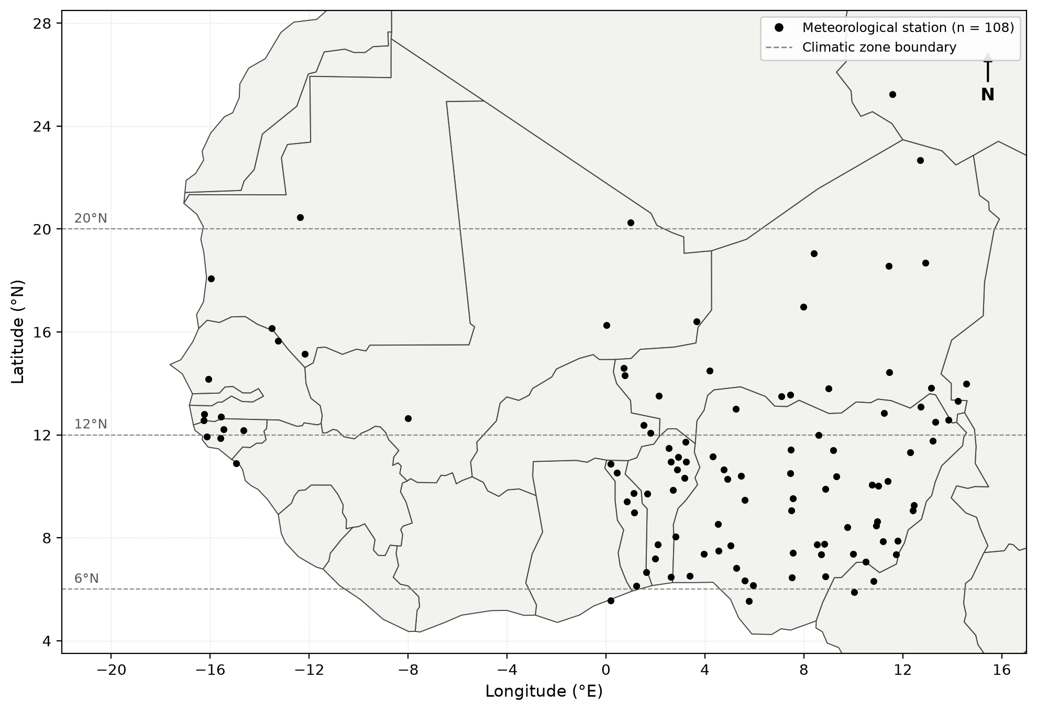
Figure 3.1: Study area showing the distribution of 108 meteorological stations across West Africa and the four climatic zones.

3.3 Spatial Interpolation Methods
Spatial interpolation is the process of estimating values of a variable at unsampled locations based on observations at nearby sample points. The choice of interpolation method depends on the nature of the spatial variation, the density and distribution of sampling points, and the specific requirements of the application (Webster and Oliver, 2007).
Deterministic Methods
Inverse Distance Weighting (IDW):
IDW is one of the simplest and most widely used interpolation methods. It estimates the value at an unsampled point as a weighted average of the values at surrounding sample points, where the weights are inversely proportional to the distance between the sample and prediction points raised to a power p (Shepard, 1968):
IDW assumes that the variable being interpolated is influenced more by nearby points than by distant ones, and that the influence decreases smoothly with distance. The method is computationally simple and requires no assumption about the statistical properties of the data. However, IDW has several limitations:
1. It does not provide any measure of prediction uncertainty.
2. It can produce artifacts (such as bull's-eye patterns) around sample points, particularly when the power parameter is high.
3. It does not account for directional trends or anisotropy in the data.
4. The predicted values are always bounded within the range of the observed values, which may not be appropriate for variables with strong trends.
The choice of the power parameter p significantly affects the interpolation results. Lower values of p produce smoother surfaces, while higher values produce more localized predictions. Watson and Philip (1985) recommended p = 2 as a reasonable default, but noted that the optimal value depends on the spatial characteristics of the data.
Radial Basis Function (RBF) Interpolation:
RBF methods fit a smooth surface that passes exactly through (or close to) the sample points by summing the contributions of radial basis functions centered at each sample point (Franke, 1982):
Geostatistical Methods
Geostatistics provides a framework for spatial interpolation that explicitly accounts for the spatial correlation structure of the data. Unlike deterministic methods, geostatistical methods provide not only predictions but also estimates of prediction uncertainty, which are essential for risk assessment and decision-making (Cressie, 1993).
The Variogram:
The fundamental tool in geostatistics is the variogram (or semivariogram), which quantifies the spatial dependence between observations as a function of the distance and direction separating them. The empirical variogram is calculated as:
 | $$γ(h)=\frac{1}{2N(h)}\sum_{i}{ }{[Z(x_{i})-Z(x_{i}+h)]}^{2}$$ | (3.1)

where N(h) is the number of pairs of points separated by the lag distance h.
The variogram typically increases from zero at h = 0 to a plateau called the sill, which represents the total variance of the data. The distance at which the sill is reached is called the range, and represents the maximum distance over which spatial correlation exists. The nugget effect, a discontinuity at the origin, represents measurement error or micro-scale variability (Webster and Oliver, 2007).
Ordinary Kriging:
Ordinary Kriging (OK) is the most commonly used kriging method. It assumes that the mean of the random field is unknown but constant within the local neighborhood of the prediction point. The kriging estimator is a weighted linear combination of the observed values:
Empirical Bayes Kriging (EBK) is a geostatistical approach that incorporates uncertainty in semivariogram parameter estimation rather than treating one fitted semivariogram as exact. It uses repeated local model estimation and simulation within an empirical-Bayesian framework, which can improve robustness when spatial structure varies across a dataset (Krivoruchko, 2012; Krivoruchko and Gribov, 2019).
In this study, EBK was evaluated alongside Ordinary Kriging and four deterministic methods using the same station network and cross-validation framework, allowing its performance to be judged empirically for the SIS dataset.
Comparison of Methods
Table 3.1: Comparison of interpolation method characteristics.
Method | Type | Complexity | Uncertainty Estimate | Handles Trends | Handles Anisotropy
IDW | Deterministic | Low | No | No | No
Ordinary Kriging | Geostatistical | High | Yes | No | Yes
EBK | Geostatistical | High | Yes | Partial | Yes
RBF | Deterministic | Medium | No | Partial | No
LPI | Deterministic | Medium | No | Yes | No
GPI | Deterministic | Low | No | Yes | No

3.4 Theoretical Framework for Spatial Analysis
Stationarity Assumptions
The validity of geostatistical methods depends on the stationarity assumptions underlying the random field model. Three levels of stationarity are recognized:
Strict stationarity: The joint probability distribution of the random field is invariant under translation. This is the strongest assumption and is rarely met in practice for environmental variables.
Second-order (weak) stationarity: The mean is constant and the covariance depends only on the lag vector, not on the location. This is the most commonly assumed form of stationarity in geostatistical practice:
 | $$E[Z(x)]=m\text{(constant)}$$ | (3.2)

 | $$Cov[Z(x),Z(x+h)]=C(h)$$ | (3.3)

Intrinsic stationarity: The mean is constant and the variogram exists and depends only on the lag vector. This is a weaker assumption than second-order stationarity and is sufficient for ordinary kriging:
 | $$E[Z(x)]=m$$ | (3.4)

 | $$Var[Z(x)-Z(x+h)]=2γ(h)$$ | (3.5)

For solar radiation in West Africa, strict stationarity is clearly violated due to the strong north-south gradient and seasonal variation. However, within local neighborhoods, the intrinsic stationarity assumption may be approximately valid, particularly for monthly climatological data where the temporal smoothing reduces non-stationarity.
Anisotropy
Anisotropy refers to the dependence of spatial correlation on direction. In solar radiation data, anisotropy may arise from:
1. Geometric anisotropy: The range of spatial correlation varies with direction but the sill remains constant. This could occur if solar radiation is more spatially correlated in the east-west direction (along latitude lines) than in the north-south direction (across climate zones).
2. Zonal anisotropy: Both the range and sill vary with direction. This is a more complex form of anisotropy that may be present in regions with strong directional trends.
In this study, we use isotropic variograms (assuming the same spatial correlation in all directions) for simplicity. However, future studies could explore the use of anisotropic variograms to better capture the directional structure of solar radiation variability.

3.5 Interpolation Methods Used in This Study
The spatial modeling framework consists of three stages: (1) computation of monthly climatologies, (2) spatial interpolation using six methods, and (3) cross-validation. The six methods were selected to represent the major categories of spatial interpolation: deterministic (IDW, RBF, LPI, GPI) and geostatistical (Ordinary Kriging, EBK). Each method has different assumptions about the spatial structure of the data and different capabilities for capturing the complex spatial patterns of solar radiation across West Africa.
a. Inverse Distance Weighting (IDW)
Inverse Distance Weighting is a deterministic interpolation method that estimates the value at an unknown point as a weighted average of nearby observed values, where the weights are inversely proportional to the distance between the prediction point and the observed stations (Shepard, 1968; Watson and Philip, 1985).
For a prediction at location x₀, the IDW estimate is given by:
 | $$Z^{*}(x_{0})=\sum_{i=1}^{n}{[}w_{i}(x_{0})·Z(x_{i})]$$ | (3.6)

where the weight function is:
 | $$w_{i}(x_{0})=\frac{1}{d(x_{0},x_{i})^{p}}$$ | (3.7)

and d(x₀, xᵢ) is the Euclidean distance between the prediction point x₀ and the observed station xᵢ, Z(xᵢ) is the observed value at station xᵢ, n is the number of stations used for prediction, and p is the power parameter.
The power parameter controls the rate at which the influence of nearby points decreases with distance. A power of p = 2 is the most commonly used value (Watson and Philip, 1985) and was adopted in this study. With p = 2, the method is equivalent to a distance-squared weighted average, giving greater influence to the nearest stations.
The weights are normalized so that they sum to unity:
 | $$\sum_{i=1}^{n}{ }w_{i}(x_{0})=1$$ | (3.8)

This ensures that the prediction is a convex combination of the observed values, which prevents extrapolation beyond the range of observed data.
b. Ordinary Kriging (OK)
Ordinary Kriging is a geostatistical interpolation method that provides the Best Linear Unbiased Estimator (BLUE) of a spatial field under the assumption of a constant but unknown mean (Matheron, 1963; Cressie, 1993). Unlike IDW, Kriging explicitly models the spatial correlation structure through the variogram, which describes how the variance of differences between observations changes with separation distance.
Variogram Model
The empirical semivariogram is computed as:
 | $$\hat{γ}(h)=\frac{1}{2N(h)}\sum_{i=1}^{N(h)}{ }{[Z(x_{i})-Z(x_{i}+h)]}^{2}$$ | (3.9)

where h is the lag vector (separation distance and direction), N(h) is the number of pairs separated by lag h, and Z(xᵢ) and Z(xᵢ + h) are the observed values at stations xᵢ and xᵢ + h, respectively.
The empirical semivariogram was fitted with an exponential model, though several other models (spherical, Gaussian, Matérn) are also used in practice:
 | $$γ(h)=c_{0}+c·[1-exp(-3|h|/a)]$$ | (3.10)

where c₀ is the nugget effect (representing measurement error and micro-scale variability), c is the sill (representing the total spatial variance), a is the range parameter (representing the distance at which spatial correlation becomes negligible), and |h| is the lag distance.
Alternative models include the spherical model, $γ(h)=c_{0}+c[1.5(h/a)-0.5(h/a)^{3}]$ for h ≤ a and $γ(h)=c_{0}+c$ for h > a, which reaches the sill at a finite distance; the Gaussian model, $γ(h)=c_{0}+c[1-exp(-h^{2}/a^{2})]$, which produces very smooth interpolated surfaces; and the Matérn model, a flexible family containing a smoothness parameter ν that controls the differentiability of the resulting field.
The practical range (the distance at which the variogram reaches 95% of the sill) is given by:
 | $$a_{\text{practical}}=3a$$ | (3.11)

Kriging System
The Ordinary Kriging predictor is a weighted linear combination:
 | $$Z^{*}(x_{0})=\sum_{j=1}^{n}{ }λ_{j}·Z(x_{j})$$ | (3.12)

where λⱼ are the Kriging weights determined by solving the system:
 | $$\sum_{j=1}^{n}{ }λ_{j}·γ(x_{i},x_{j})+μ=γ(x_{0},x_{i}),i=1,…,n$$ | (3.13)

 | $$\sum_{j=1}^{n}{ }λ_{j}=1$$ | (3.14)

where μ is the Lagrange multiplier enforcing the unbiasedness constraint (the weights sum to unity), and γ(xᵢ, xⱼ) is the semivariogram value between stations xᵢ and xⱼ.
In matrix form, the system is:
 | $$Γ·λ=γ_{0}$$ | (3.15)

where Γ is the n×n matrix of semivariogram values between all pairs of stations, λ is the vector of Kriging weights, and γ₀ is the vector of semivariogram values between stations and the prediction point.
The Kriging variance (prediction uncertainty) is:
 | $$σ_{K}^{2}(x_{0})=\sum_{j=1}^{n}{ }λ_{j}·γ(x_{0},x_{j})+μ$$ | (3.16)

This provides a measure of prediction uncertainty at each location, which is a key advantage of Kriging over deterministic methods.
Advantages of Ordinary Kriging: OK accounts for spatial correlation through the variogram, derives interpolation weights from the modeled spatial structure, and provides a Kriging variance that can be used as a measure of prediction uncertainty. It is a well-established geostatistical method, but its reliability depends on appropriate variogram estimation and model specification (Oliver and Webster, 2014).
Another variant, Universal Kriging (UK), extends OK by modelling the mean as a polynomial trend of the coordinates, allowing large-scale trends to be accounted for at the cost of a more complex kriging system.
A variant, Simple Kriging (SK), assumes that the mean of the random field is known and constant across the study area; it yields lower kriging variances than OK when the mean is correctly specified, but this assumption is rarely met in practice.
c. Empirical Bayes Kriging (EBK)
Empirical Bayes Kriging automates local semivariogram estimation and incorporates uncertainty in semivariogram parameters through an empirical-Bayesian framework (Krivoruchko, 2012; Krivoruchko and Gribov, 2019). It can be useful for heterogeneous datasets because model parameters are estimated repeatedly within local subsets rather than relying on one fixed global semivariogram.
Step 1: Data Transformation Used in This Study
EBK does not inherently require a log-normal distribution. In ArcGIS, transformations are optional. For this study, the Log Empirical transformation was selected for the positive SIS values as part of the EBK configuration.
The transformation and subsequent prediction-scale handling were performed within ArcGIS Geostatistical Analyst rather than by applying a separate manual back-transformation equation.
This distinction is important because the transformation is an implementation choice used in this analysis, not a universal assumption of the EBK method.
Step 2: Local Semivariogram Estimation
EBK partitions observations into local, overlapping subsets and repeatedly estimates semivariogram models within those subsets. This allows moderate changes in spatial structure across the study area to be represented more flexibly than with one global semivariogram.
Step 3: Empirical-Bayesian Prediction
Within each local subset, EBK generates a distribution of plausible semivariogram models and uses them in the prediction process. The resulting prediction therefore reflects uncertainty in semivariogram estimation rather than conditioning on a single fitted model.
Step 4: Study Configuration
The ArcGIS implementation used the Log Empirical transformation, K-Bessel semivariogram model, and 100 simulations, as summarized in Section 3.6.1.
Predictions and associated standard errors were generated by ArcGIS on the configured output scale; no separate manual back-transformation equation was applied outside the software.
These settings were applied consistently to the monthly SIS climatologies so that EBK could be compared with the other interpolation methods under the same cross-validation framework.
Advantages of EBK: EBK reduces dependence on a single manually fitted semivariogram, can adapt to moderate local non-stationarity, and explicitly accounts for semivariogram-parameter uncertainty. Its actual advantage over other methods remains dataset-specific and was therefore assessed through cross-validation (Krivoruchko and Gribov, 2019).
d. Radial Basis Function (RBF)
Radial Basis Function interpolation is a deterministic method that constructs a smooth surface by summing radial basis functions centered at each observed station (Franke, 1982; Hastie et al., 2009). The predicted value is:
 | $$Z^{*}(x_{0})=\sum_{j=1}^{n}{ }λ_{j}·φ(d(x_{0},x_{j}))$$ | (3.17)

where λⱼ are the coefficients to be determined, d(x₀, xⱼ) is the distance between the prediction point and station xⱼ, and φ(r) is the radial basis function.
Several types of RBF are available, including the thin-plate spline $φ(r)=r^{2}ln(r)$, the multiquadric $φ(r)=\sqrt{r^{2}+δ^{2}}$, where δ is a shape parameter, and the Gaussian $φ(r)=exp(-r^{2}/δ^{2})$. In this study, the thin-plate spline was used, which has the form:
 | $$φ(r)=r^{2}·ln(r)$$ | (3.18)

The thin-plate spline produces the smoothest possible surface that passes through all observed data points, making it suitable for modeling smooth, continuous fields such as solar radiation (Watson, 1984).
The coefficients λⱼ are determined by solving the system:
 | $$Φ·λ=Z$$ | (3.19)

where Φ is the n×n matrix with elements Φᵢⱼ = φ(d(xᵢ, xⱼ)), λ is the vector of coefficients, and Z is the vector of observed values.
In contrast to Kriging, RBF surfaces interpolate exactly at the data points used for fitting, but they do not provide a measure of prediction uncertainty, and performance may degrade in the presence of measurement errors or when extrapolating beyond the data coverage.
Advantages of RBF: RBF does not require variogram modeling, can produce smooth continuous surfaces, and is computationally efficient. It is an exact interpolator at the observations used to fit a surface, but that property does not guarantee good leave-one-out performance because each validation station is excluded from the fit used to predict it.
e. Local Polynomial Interpolation (LPI)
Local Polynomial Interpolation fits a polynomial regression model within a moving window centered at each prediction point (Cressie, 1993). At each prediction location x₀, a local neighborhood of n nearest stations is selected, and a polynomial of order p is fitted:
 | $$Z^{*}(x)=\sum_{k=0}^{p}{ }\sum_{j=0}^{k}{ }β_{jk}·(x-x_{0})^{j}·(y-y_{0})^{k-j}$$ | (3.20)

For a first-order polynomial (p = 1), the model is:
 | $$Z^{*}(x_{0},y_{0})=β_{0}+β_{1}x_{0}+β_{2}y_{0}$$ | (3.21)

The coefficients β₀, β₁, β₂ are estimated by weighted least squares, where the weights decrease with distance from the prediction point. The bandwidth (window size) determines the number of stations included in the local fit.
Limitations: LPI is more flexible than GPI but is sensitive to the choice of polynomial order and window size, and can produce unstable predictions at the edges of the study area where fewer stations are available, and the method cannot capture complex spatial patterns that deviate from the polynomial trend (Webster and Oliver, 2007).
f. Global Polynomial Interpolation (GPI)
Global Polynomial Interpolation fits a single polynomial to the entire dataset:
 | $$Z^{*}(x,y)=β_{0}+β_{1}x+β_{2}y+⋯+β_{p}x^{p}y^{0}+⋯+β_{k}x^{0}y^{p}$$ | (3.22)

For a first-order polynomial (p = 1), the model reduces to:
 | $$Z^{*}(x,y)=β_{0}+β_{1}x+β_{2}y$$ | (3.23)

The coefficients are estimated by ordinary least squares using all n stations simultaneously, producing a global trend surface that captures only the large-scale spatial gradient. Higher-order polynomials can capture more complex trends but are prone to overfitting and can produce unrealistic extrapolations.
Limitations: GPI can only capture broad, large-scale trends and cannot represent local variations. In regions with complex spatial patterns, such as West Africa with its strong north-south gradient and seasonal variability, GPI tends to produce very poor predictions with large residuals (Franke, 1982). The method is most useful as a detrending tool in hybrid approaches such as regression-kriging.

3.6 Assessment of Interpolation Methods
Root Mean Square Error (RMSE):
 | $$RMSE=\sqrt{\frac{1}{n}\sum_{i=1}^{n}{ }{(Z_{i}-Z_{i}^{*})}^{2}}$$ | (3.24)

RMSE measures the overall magnitude of prediction errors, with lower values indicating better accuracy. It is sensitive to outliers due to the squaring of errors.
Mean Absolute Error (MAE):
 | $$MAE=\frac{1}{n}\sum_{i=1}^{n}{|Z_{i}-Z_{i}^{*}|}$$ | (3.25)

MAE provides a robust measure of average prediction error magnitude that is less sensitive to outliers than RMSE.
Mean Error (ME):
 | $$ME=\frac{1}{n}\sum_{i=1}^{n}{(Z_{i}^{*}-Z_{i})}$$ | (3.26)

ME measures the systematic bias of predictions. A ME close to zero indicates unbiased predictions, while positive ME indicates overestimation and negative ME indicates underestimation.
Median Absolute Error (MedAE):
 | $$\text{MedAE}=\text{median}(|Z_{i}-Z_{i}^{*}|)$$ | (3.27)

MedAE is a robust measure of central tendency for prediction errors, unaffected by extreme values. This is particularly important for methods like GPI and LPI that may produce occasional extreme errors.
Coefficient of Determination (R²):
 | $$R^{2}=1-\frac{\sum_{i=1}^{n}{ }{(Z_{i}-Z_{i}^{*})}^{2}}{\sum_{i=1}^{n}{ }{(Z_{i}-\overline{Z})}^{2}}$$ | (3.28)

R² measures the proportion of variance in the observed data that is explained by the predictions. Values close to 1 indicate excellent agreement between predictions and observations.

CHAPTER FOUR

RESULTS AND DISCUSSION

4.1 Monthly Spatial comparison of Solar Radiation from Geostatistical methods
General Patterns
The interpolated SIS surfaces reveal consistent spatial patterns across all methods:
1. North-south gradient: The interpolated surfaces show SIS increasing from south to north, from approximately 4,000 Wh/m² in the coastal zone to more than 6,500 Wh/m² near the Saharan edge. This pattern is consistent with the broad climatic and solar-geometry gradient across the study domain, reflecting the combined influence of latitude, cloudiness, and atmospheric conditions.
2. Seasonal variation: The spatial pattern changes markedly across the annual cycle, with pronounced contrasts during several transition months. The maps show weaker and stronger north-south gradients at different times of year; these changes are consistent with the seasonal evolution of cloudiness described for West Africa (Tanu et al., 2021; Sawadogo et al., 2023).
3. Local variations: The interpolated surfaces show departures from the broad regional gradient near several areas, including central Nigeria, the Fouta Djallon region, and the coast. These local features coincide with geographic and station-network differences, including topographic effects and proximity to water bodies.
4. Zonal contrasts: Strong spatial contrasts are visible in several transition-season maps. Their timing is broadly consistent with the seasonal migration of the West African rain belt.
Seasonal Patterns
Dry Season (December–February):
The dry-season maps generally show relatively high SIS over much of the Sahel and northern Guinea savanna, with more moderate values toward the coast. Harmattan dust is a known regional influence during this period and contributes to the attenuation of surface radiation in the northern zones.
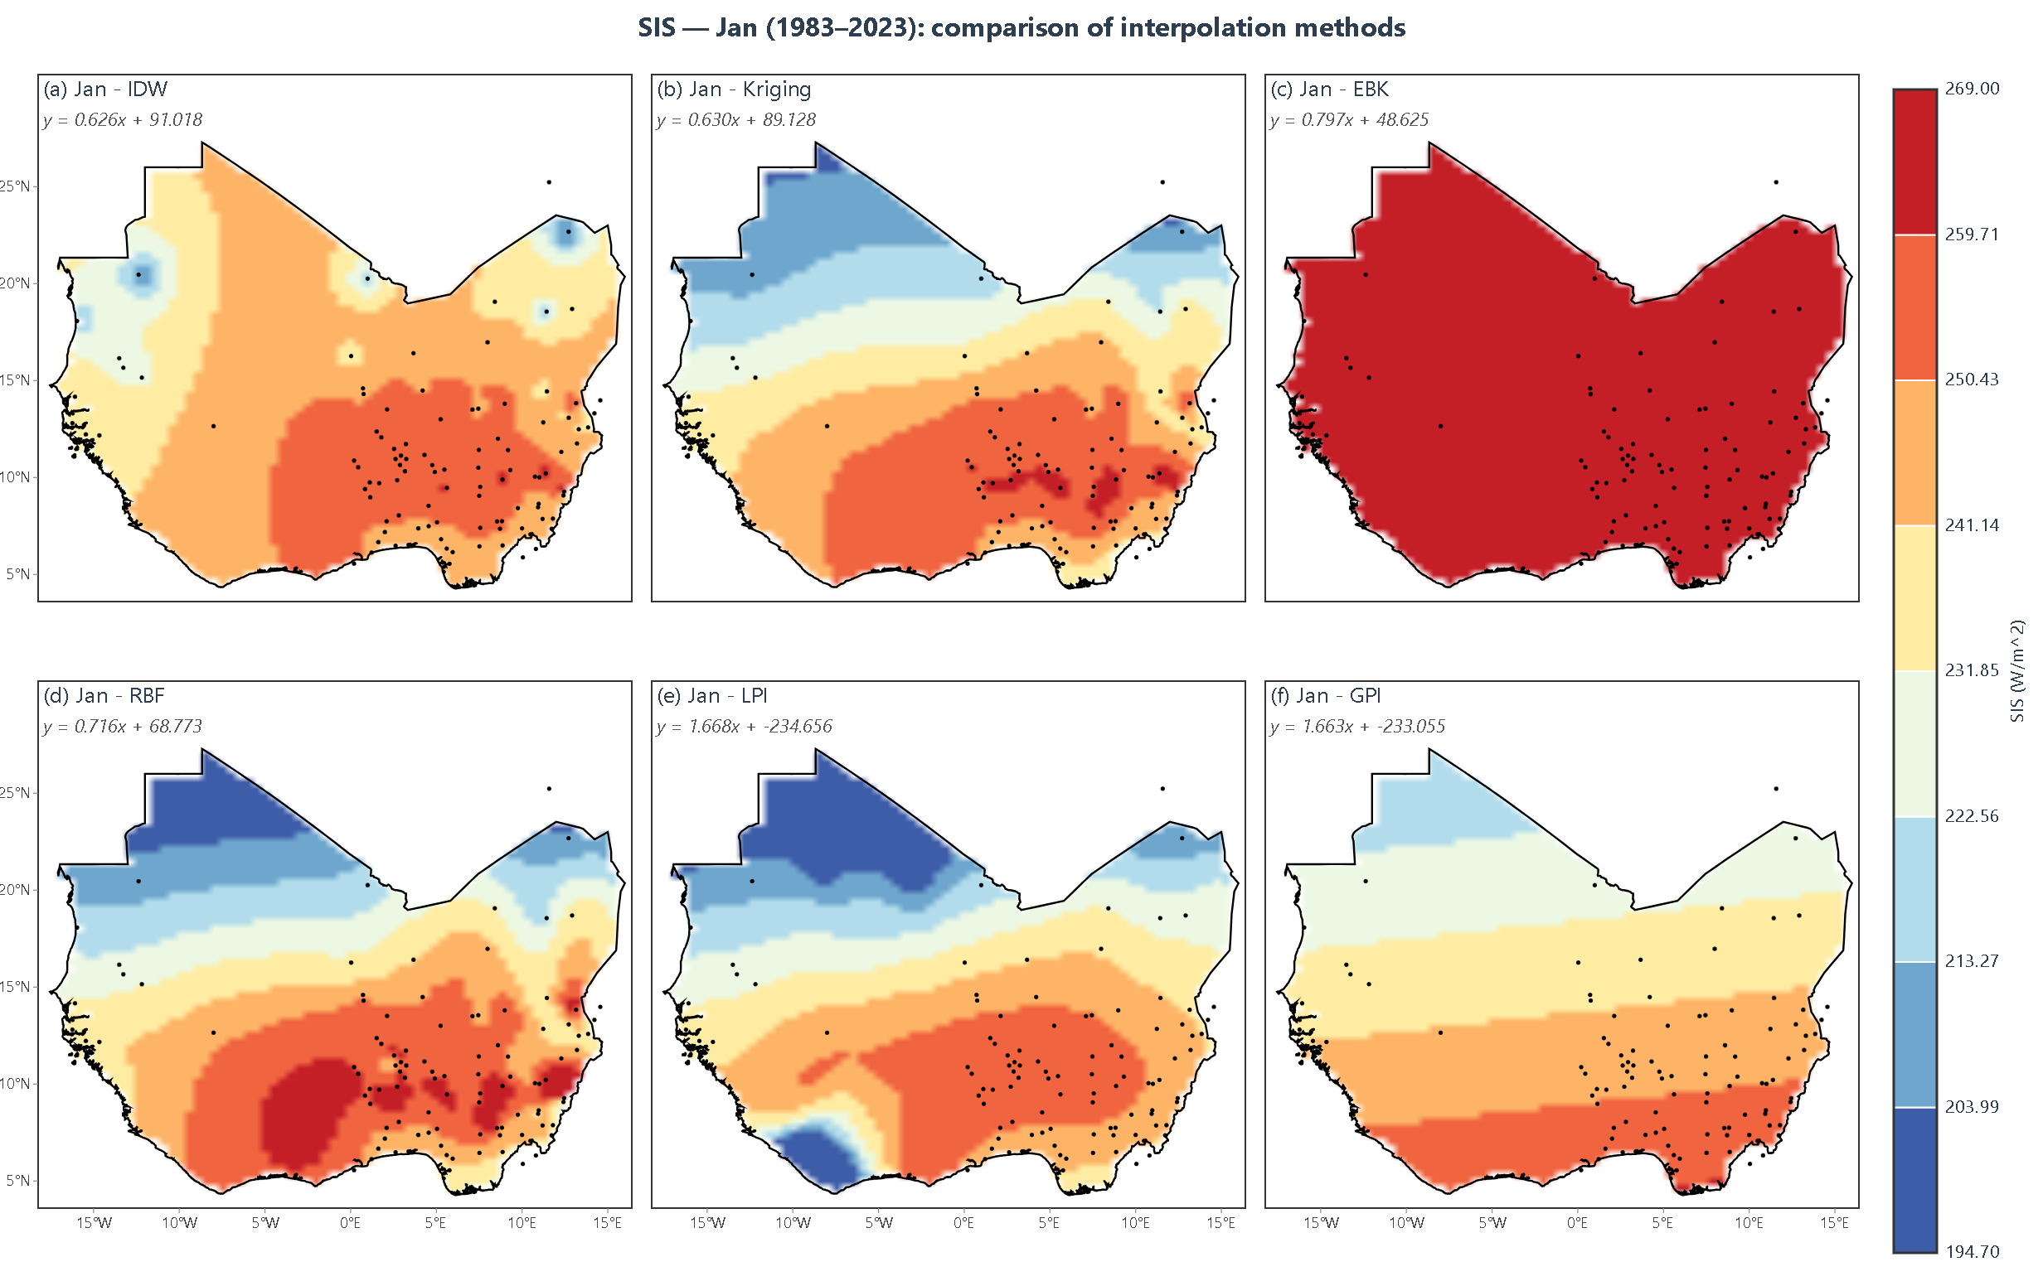
Figure 4.1: January SIS interpolation showing all six methods side by side
January Analysis: The January interpolation maps (Figure 4.1) show a relatively uniform large-scale pattern across the six methods, with a weak north-south gradient and SIS values of roughly 4,800 Wh/m² along the coast to about 6,200 Wh/m² in the northern Sahel. This pattern is consistent with dry-season conditions, when clear skies and the Harmattan shape the surface radiation field.
All six methods produce broadly similar patterns for January, though differences are visible in the smoothness of the surfaces. IDW produces a relatively smooth surface with gradual transitions, while Kriging and EBK capture more local detail near stations with higher SIS values. RBF produces the smoothest surface of all methods, with continuous gradients that reflect the thin-plate spline's tendency to minimize surface curvature. GPI and LPI produce overly simplistic surfaces that fail to capture the subtle regional variations.
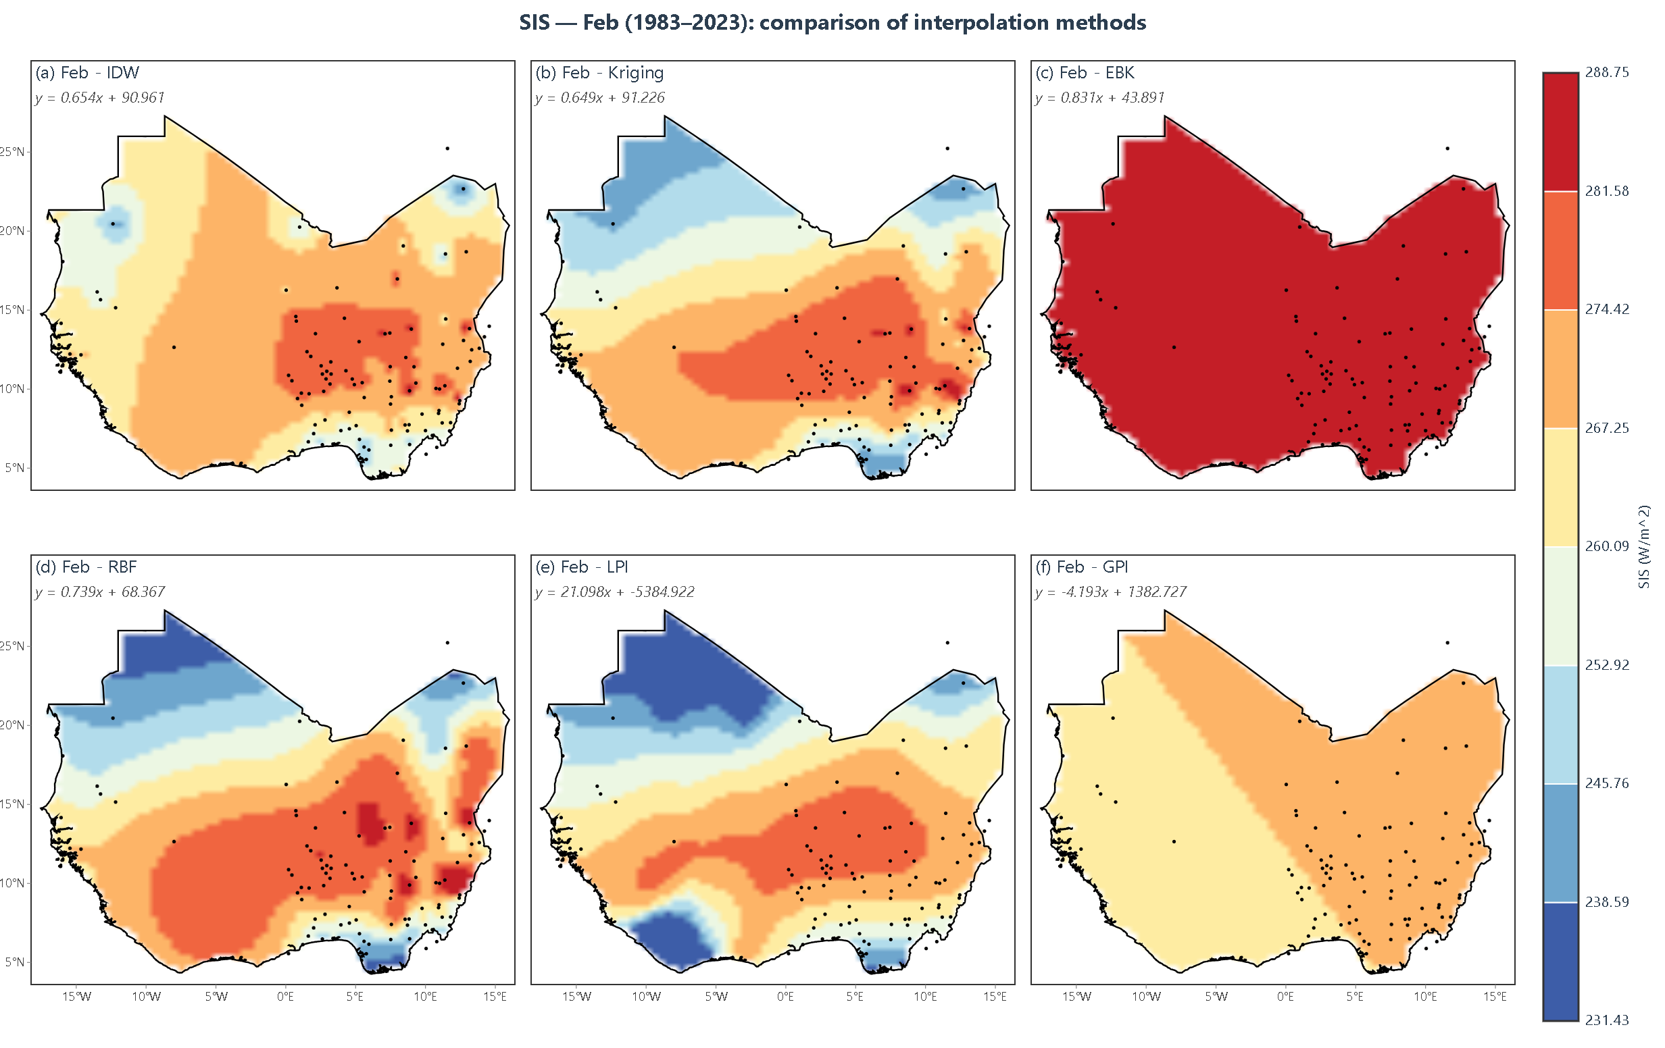
Figure 4.2: February SIS interpolation showing all six methods side by side
February Analysis: The February maps (Figure 4.2) remain broadly similar to January, with a weak north-south gradient and generally high SIS values. Some regional differences from January are visible, reflecting the evolving influence of dust and cloudiness between the two months.
The performance differences between methods are more apparent in February. Kriging and EBK produce sharper gradients near the transition between the Sahel and Guinea savanna zones, reflecting their ability to model spatial correlation structures. IDW produces a more diffuse pattern that smooths over these transitions. RBF produces a very smooth surface that captures the broad gradient but misses local variations.
Transition Season (March–May):
During March–May the maps develop a stronger south-to-north contrast, with lower SIS in the south and higher SIS toward the Sahel and Saharan margin. This evolution is broadly consistent with the seasonal transition in West African cloud conditions.
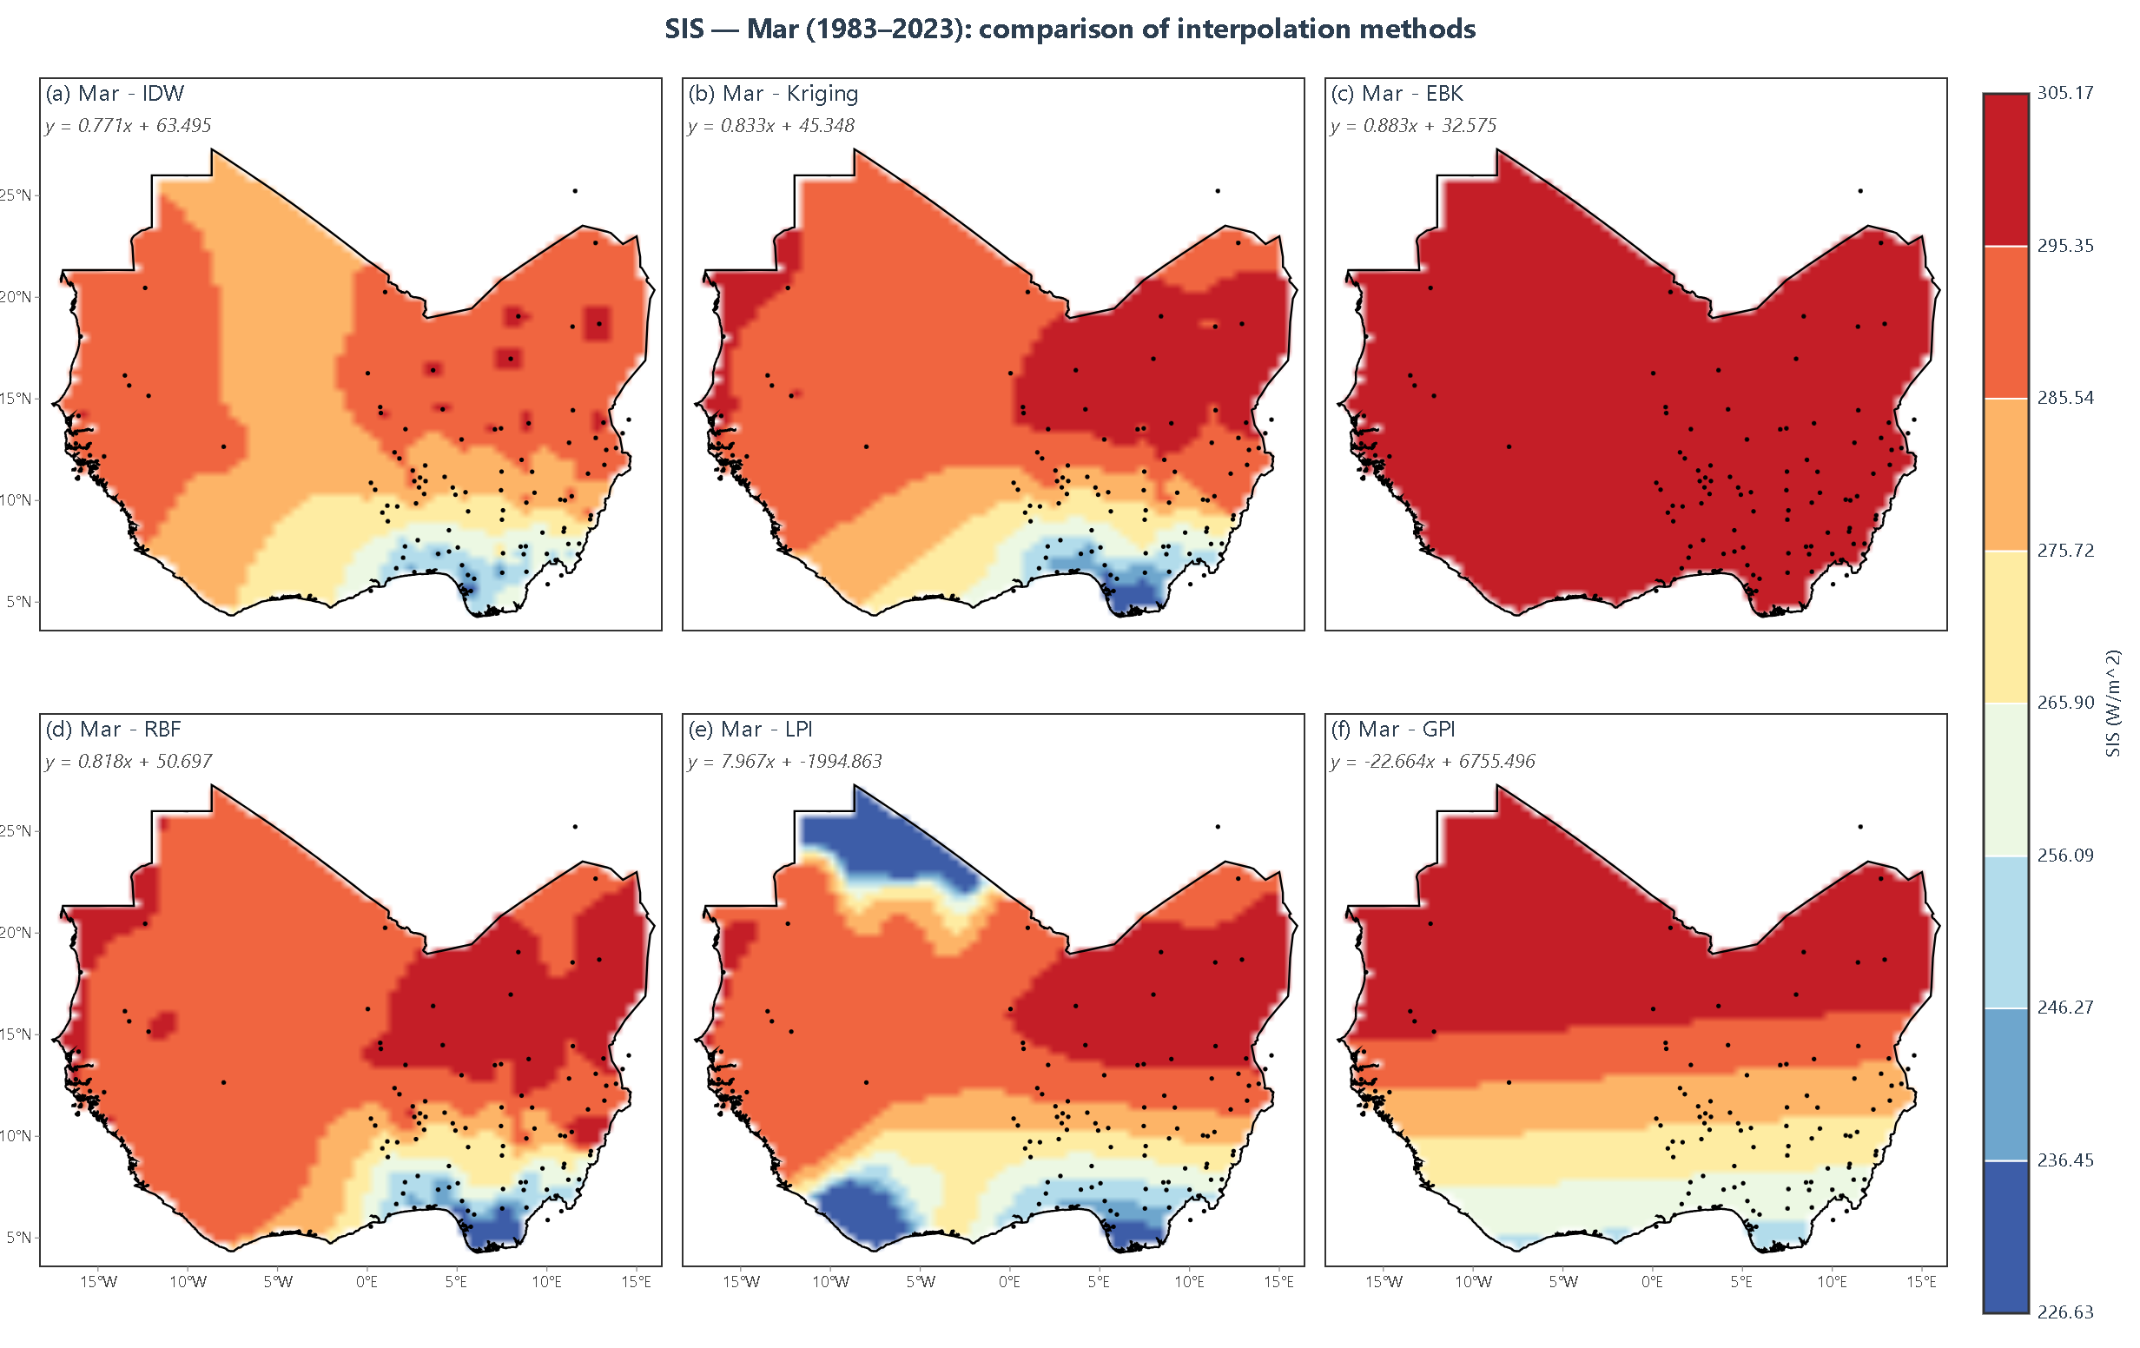
Figure 4.3: March SIS interpolation showing all six methods side by side
March Analysis: The March maps (Figure 4.3) show a stronger north-south gradient than January and February. Coastal SIS is approximately 4,000–4,500 Wh/m², while values above 6,000 Wh/m² occur farther north. The resulting band of intermediate values across the central study domain corresponds to the transition between the cloudy coastal zone and the clearer interior.
The methods diverge more visibly in March. Kriging and EBK retain relatively detailed spatial structure, whereas RBF and IDW produce smoother transitions. GPI and LPI provide much broader trend surfaces. These visual differences should be interpreted together with cross-validation rather than treated as evidence that a sharper-looking surface is necessarily more accurate.
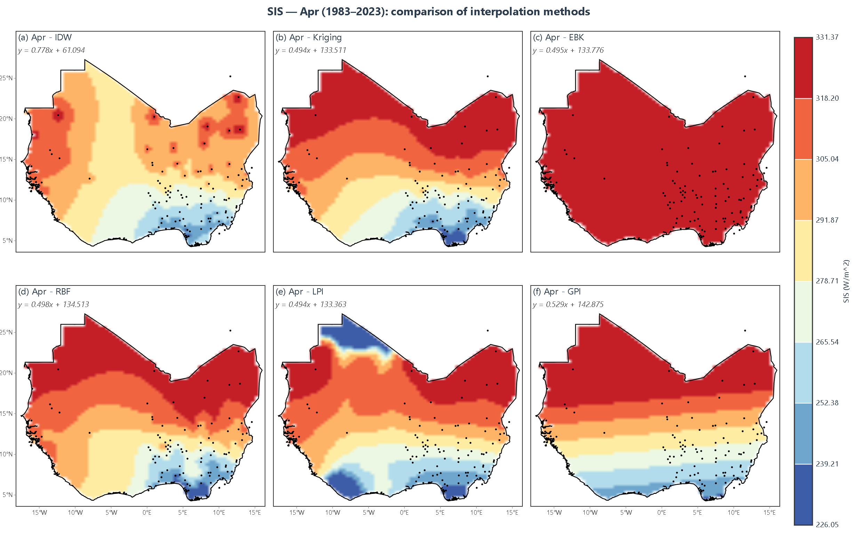
Figure 4.4: April SIS interpolation showing all six methods side by side
April Analysis: The April maps (Figure 4.4) show a pronounced north-south SIS gradient, with lower values in the south and values above 6,000 Wh/m² toward the northern part of the study area. This spatial contrast is consistent with the seasonal transition, as the monsoon front moves northward and clears the interior.
The interpolation methods represent the April gradient differently. Kriging and EBK preserve more local spatial detail, while RBF and IDW generate smoother transitions. The cross-validation metrics in Table 4.7 provide the quantitative basis for judging accuracy; visual sharpness alone is not used as an accuracy criterion.
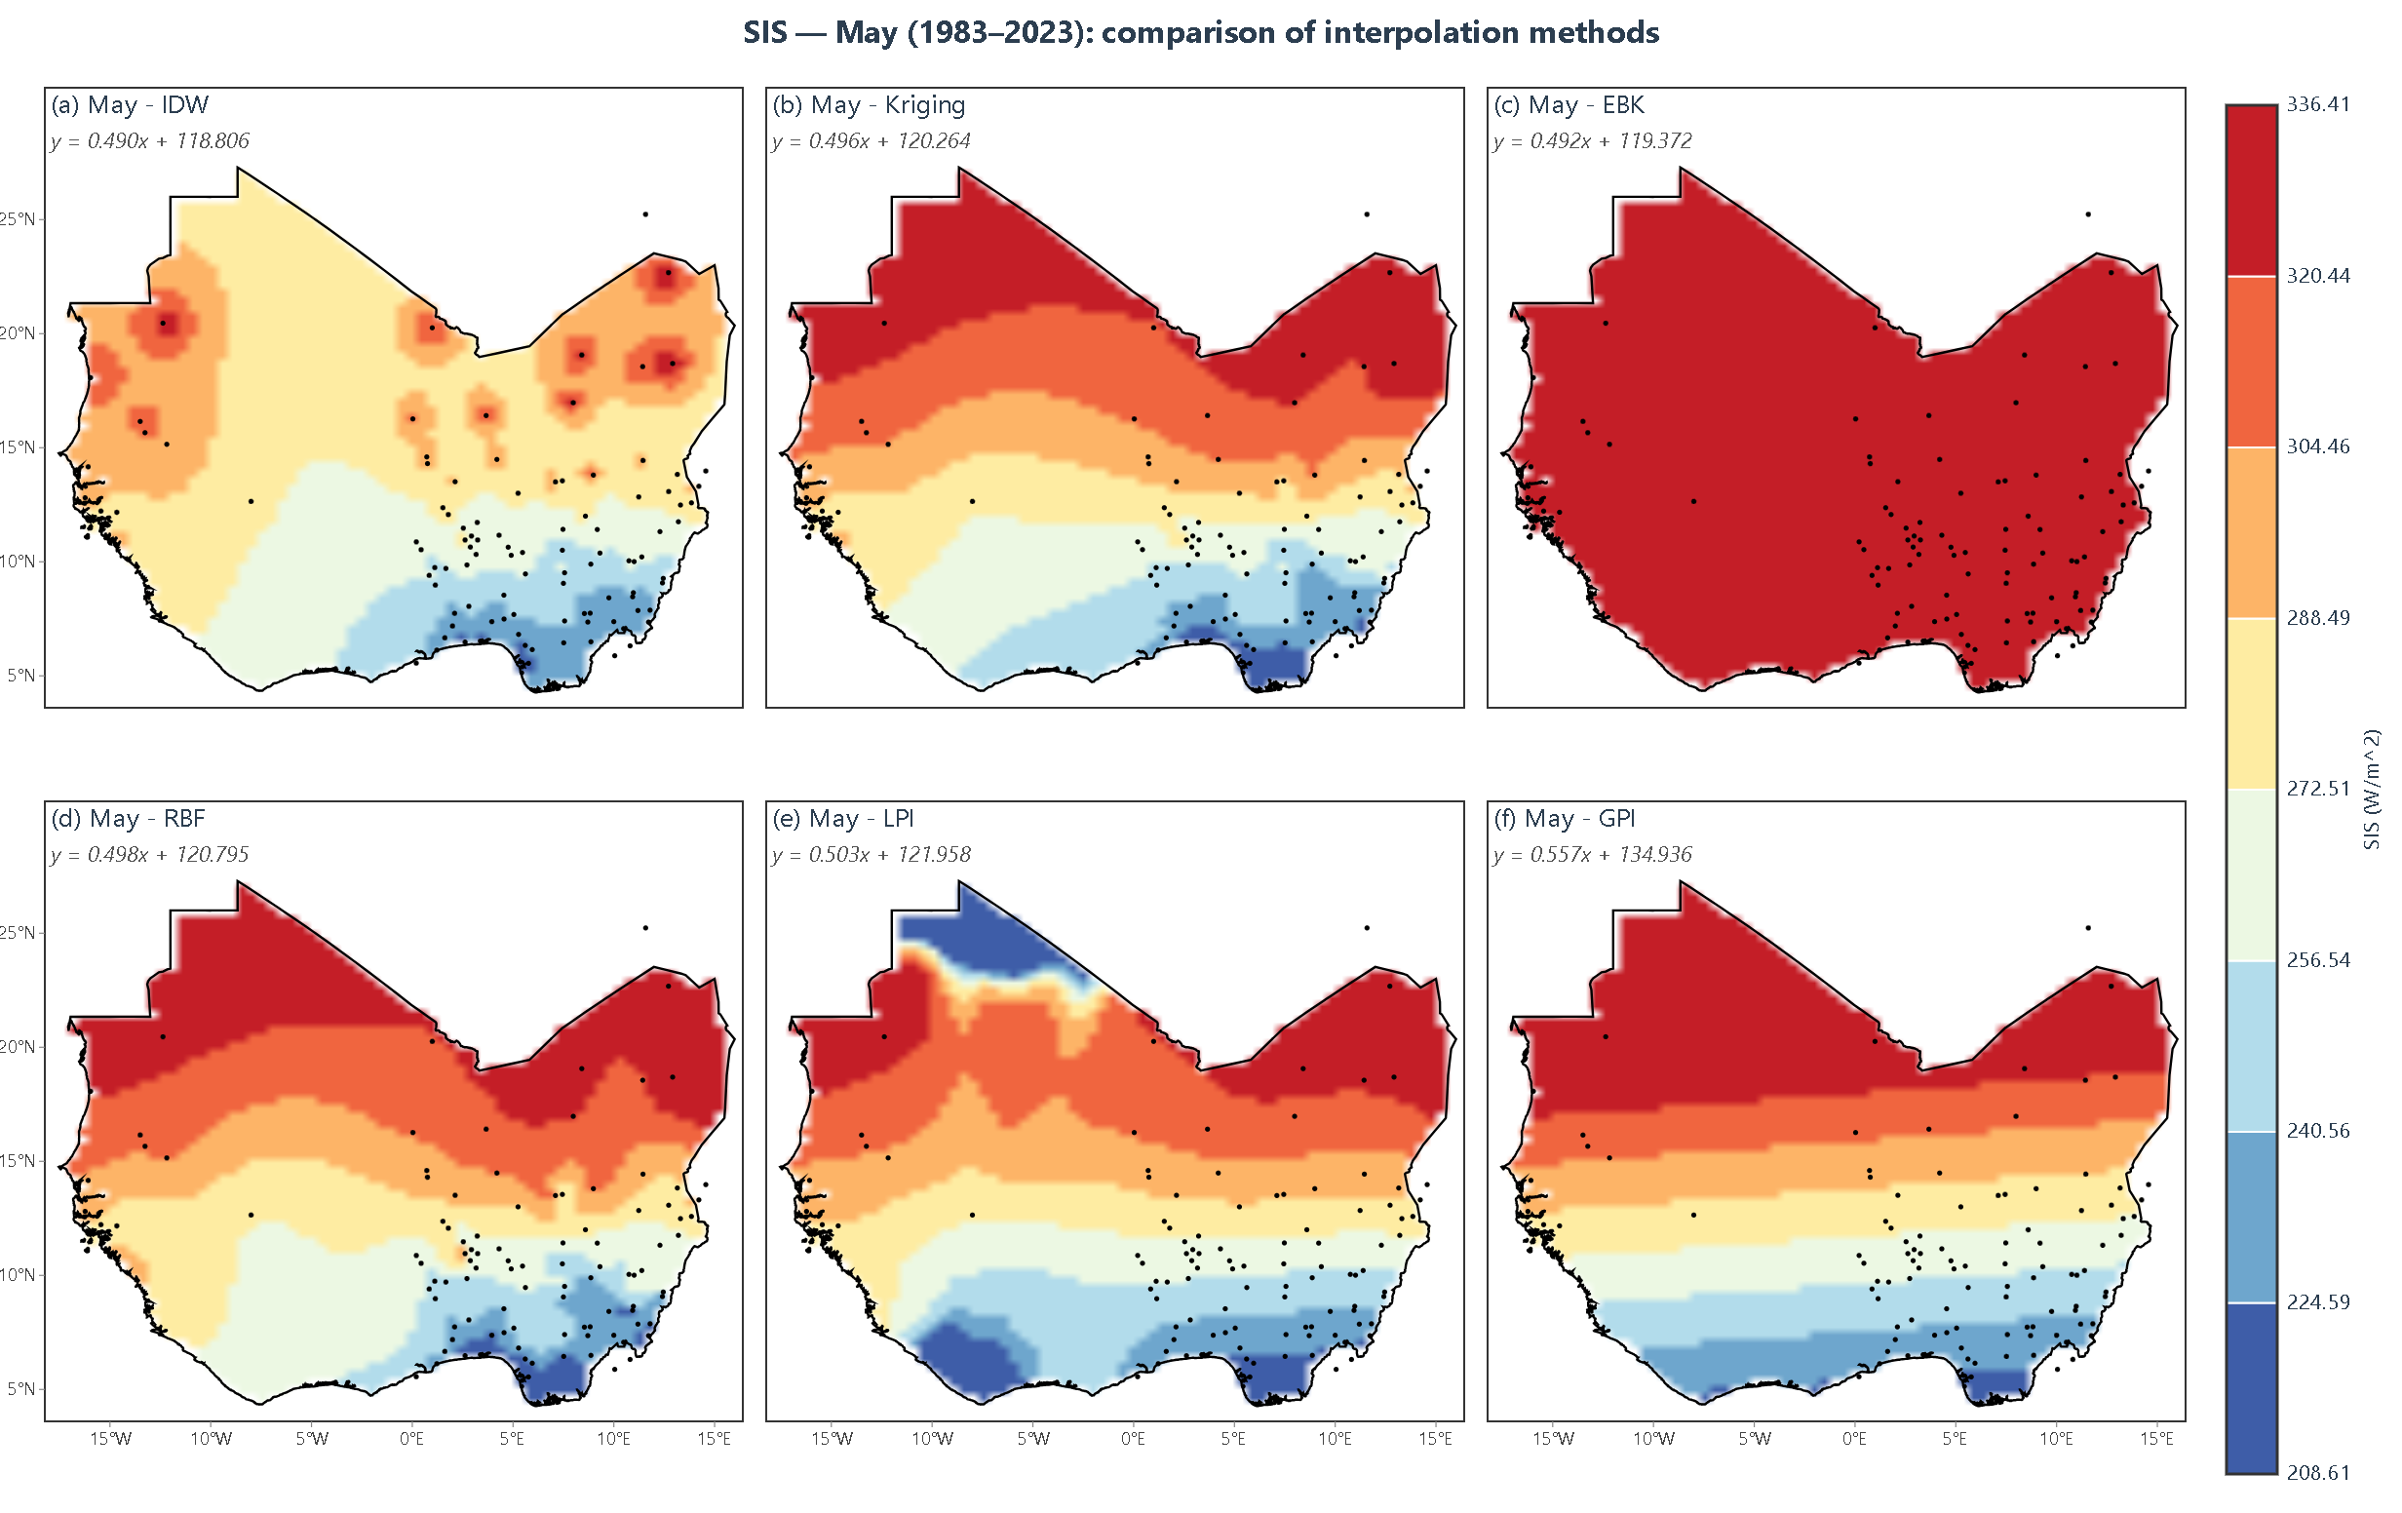
Figure 4.5: May SIS interpolation showing all six methods side by side
May Analysis: The May maps (Figure 4.5) show a strong south-to-north contrast, with coastal values around 3,000–3,500 Wh/m² and higher values farther north. The large regional range is consistent with the seasonal evolution of SIS across West Africa during the transition into the rainy season.
The methods show substantial visual differences in May. Kriging and EBK preserve more localized structure, RBF produces a smooth regional surface, and IDW is more strongly influenced by nearby station values. GPI and LPI produce broad polynomial trends. Quantitative comparison is therefore based primarily on the cross-validation metrics rather than on visual complexity.
Rainy Season (June–September):
The June–September maps generally show lower SIS across much of the southern and central study area than in the preceding transition months. This pattern is consistent with the West African rainy season, which reduces surface radiation across much of the study area through extensive cloud cover.
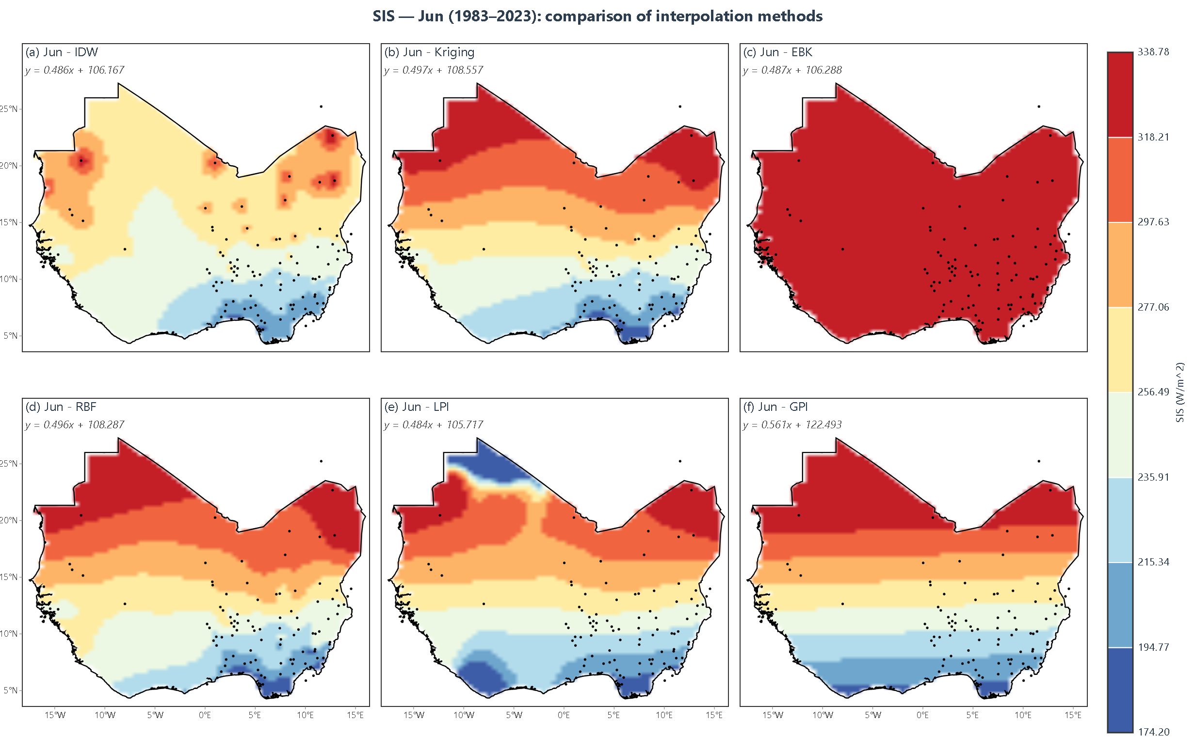
Figure 4.6: June SIS interpolation showing all six methods side by side
June Analysis: The June maps (Figure 4.6) show lower SIS across much of the area south of about 15°N and higher values toward the Saharan margin. Coastal values are approximately 3,000–3,500 Wh/m², while northern values remain higher. The mapped gradient reflects the extensive cloud cover of the early rainy season across the southern half of the study area.
From May to June, RMSE increases for Kriging, RBF, EBK, and IDW. This month-to-month change coincides with the more extensive cloud conditions of the early rainy season, which increase the spatial complexity that the interpolation methods must capture. Kriging and EBK continue to show detailed spatial structure, RBF remains comparatively accurate, and IDW has the largest June RMSE among Kriging, RBF, EBK, and IDW.
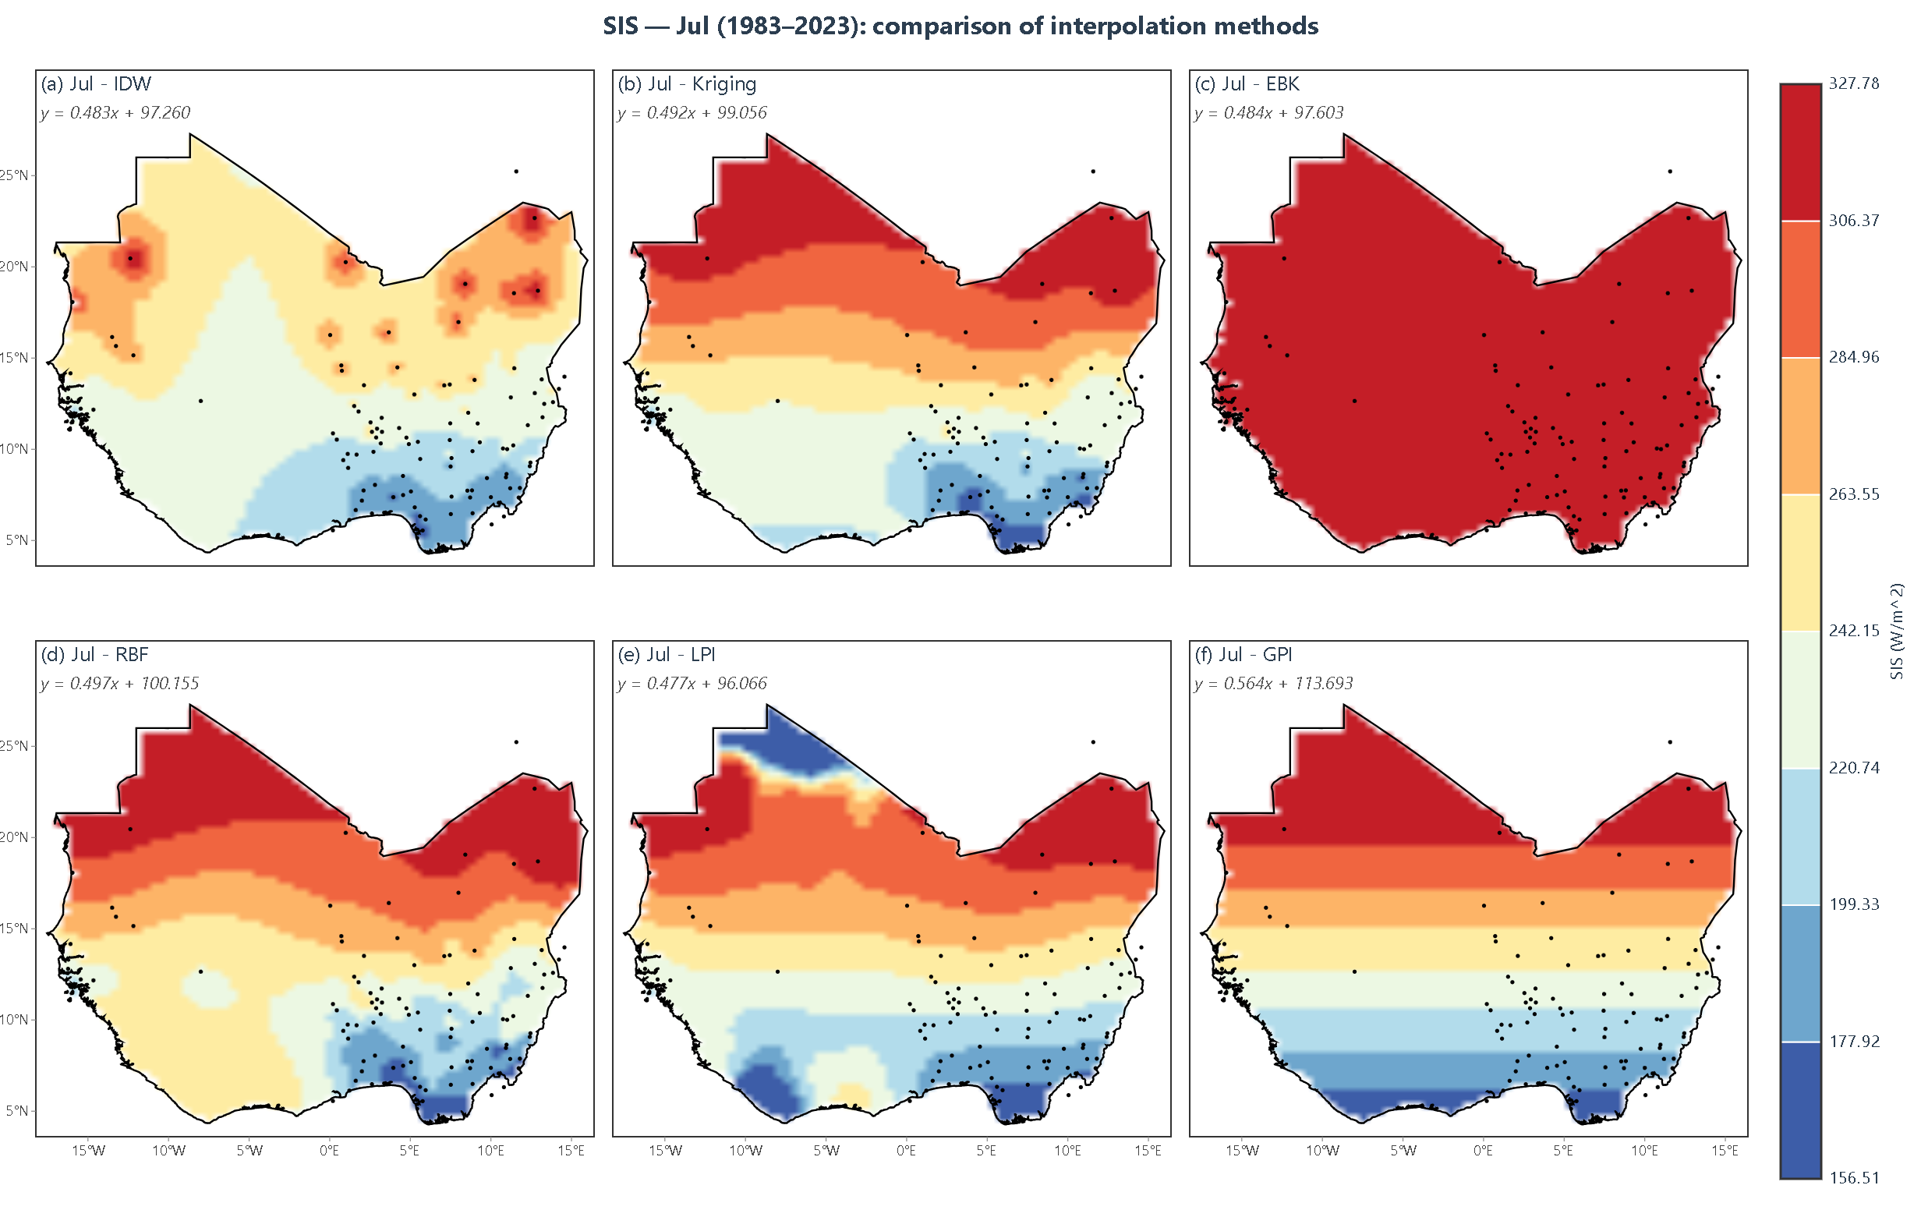
Figure 4.7: July SIS interpolation showing all six methods side by side
July Analysis: The July maps (Figure 4.7) show low SIS in the coastal zone and reduced values across parts of the Sahel relative to several earlier months. The north-south contrast also changes from the May pattern. These changes coincide with the regional rainy season, whose extensive cloud cover reduces surface radiation across much of the study area.
July produces higher RMSE than June for Kriging, EBK, and IDW, whereas RBF improves from 1.87 to 1.20 Wh/m². The month therefore illustrates that interpolation performance responds differently by method under the same seasonal conditions. The maps remain more irregular than in some earlier months, but the numerical results do not show a uniform loss of accuracy across all methods.
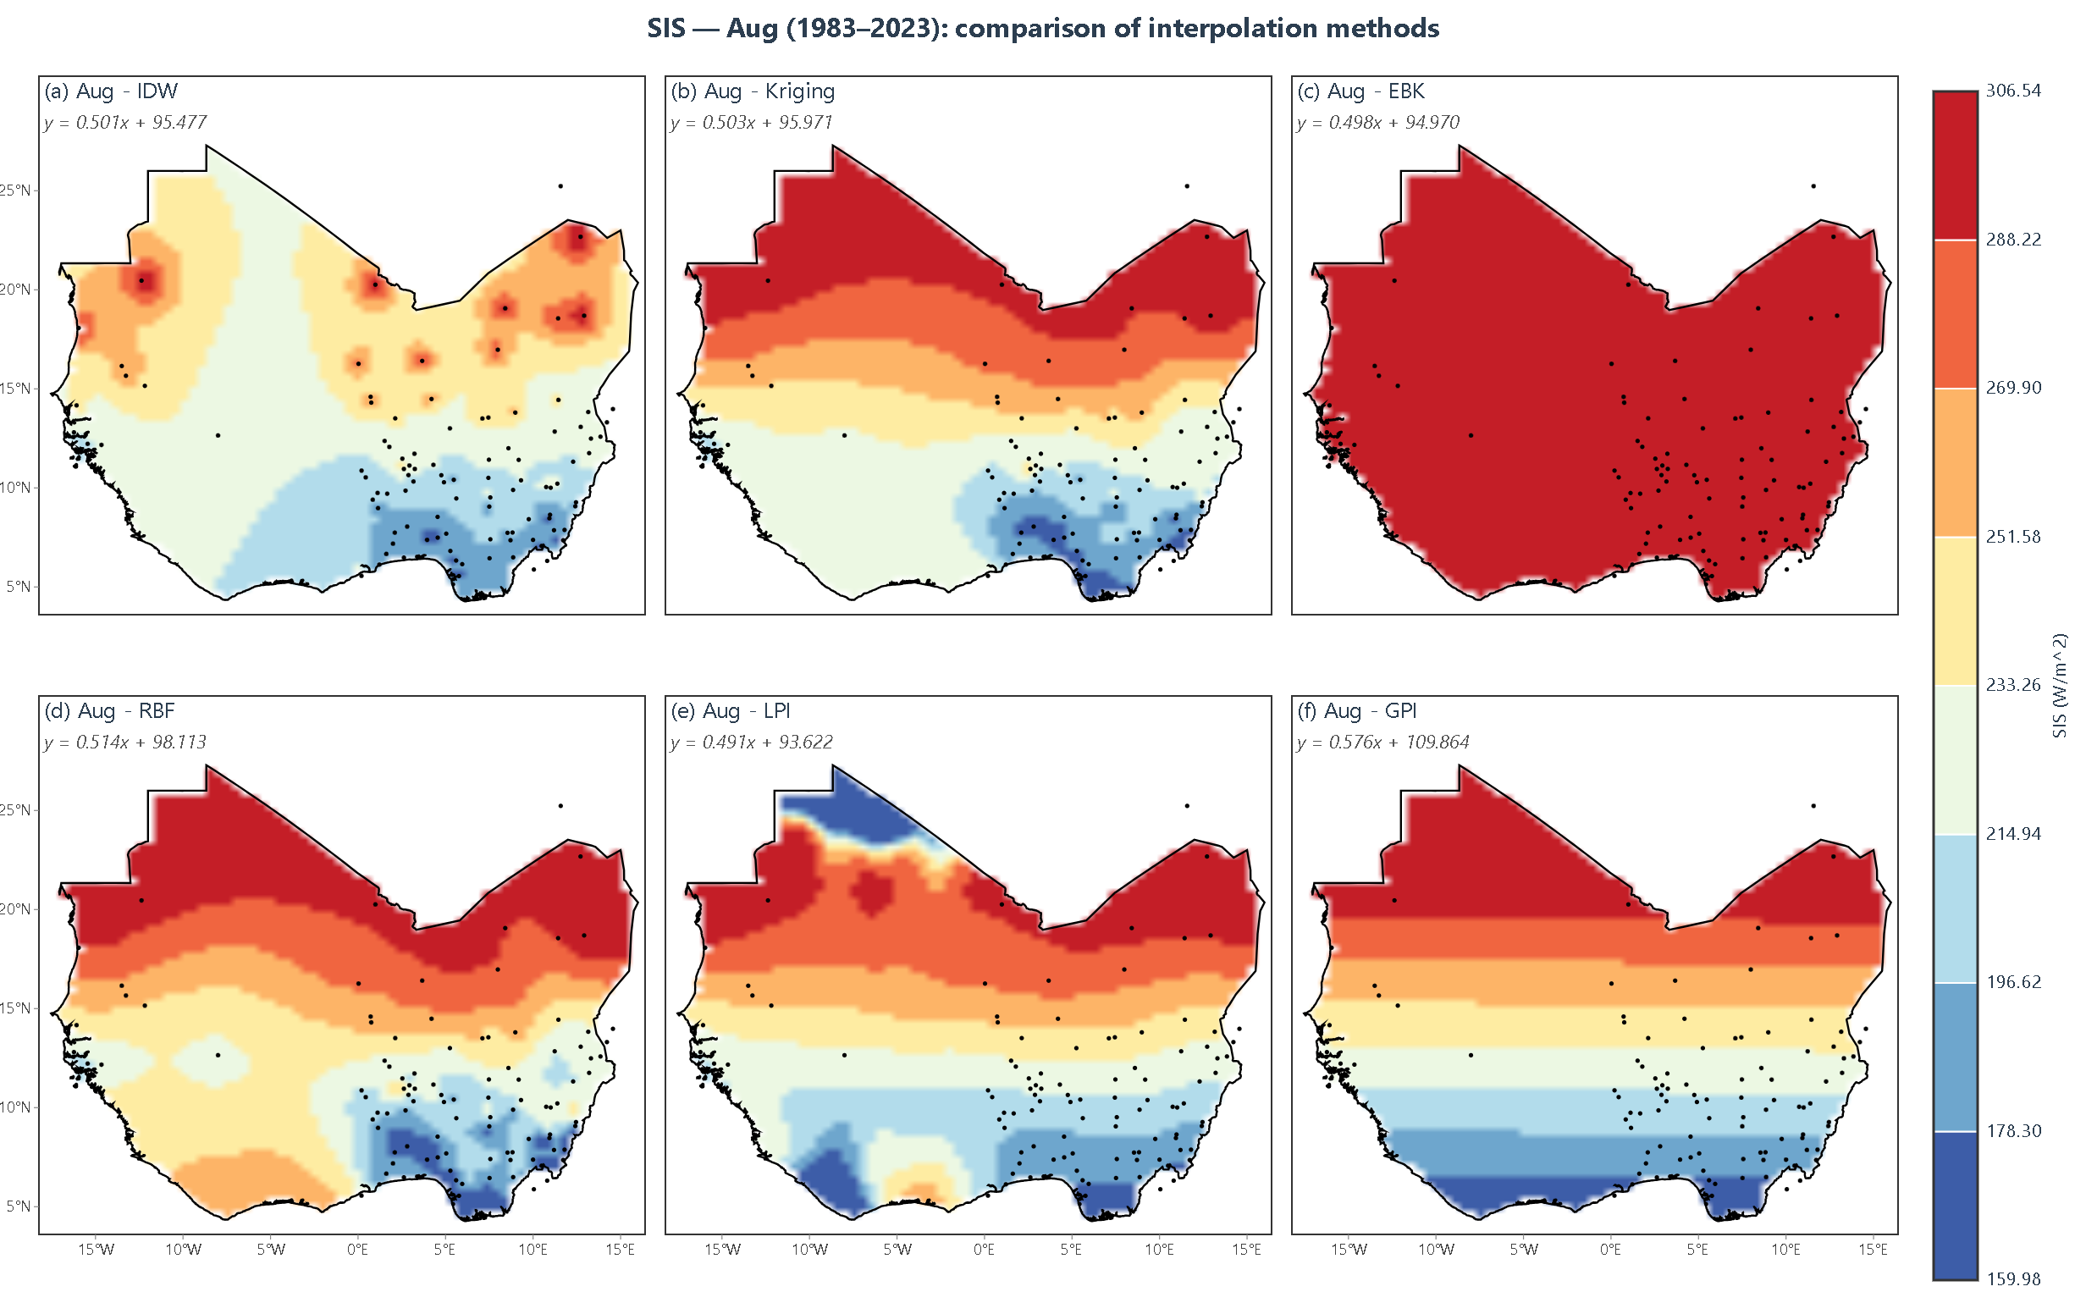
Figure 4.8: August SIS interpolation showing all six methods side by side
August Analysis: The August maps (Figure 4.8) show a large-scale pattern broadly similar to July, with relatively low SIS over much of the southern and central study area. Some regional differences from July are visible, consistent with the continued influence of the monsoon cloud band.
The August cross-validation results are strongly method-dependent: IDW records the lowest RMSE (0.19 Wh/m²), EBK also performs well (0.82 Wh/m²), whereas RBF records a much larger error (5.47 Wh/m²). This pattern cautions against describing August as uniformly difficult for all methods or attributing the error differences to a single seasonal mechanism without additional testing.
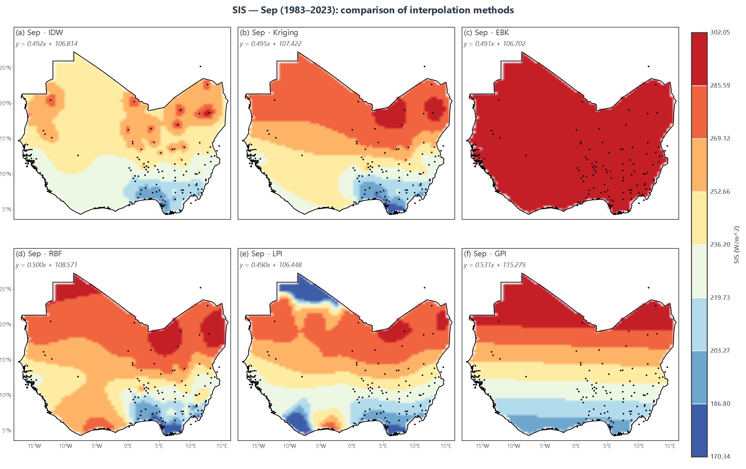
Figure 4.9: September SIS interpolation showing all six methods side by side
September Analysis: The September maps (Figure 4.9) show a renewed north-south contrast, with higher SIS toward the Sahel and lower values near the coast. This pattern is consistent with the seasonal transition out of the main rainy period as the monsoon begins its retreat.
September performance is highly method-specific. RBF records a very low RMSE (0.08 Wh/m²), while the other three reported methods have RMSE values around 3.5–3.8 Wh/m². The numerical results therefore provide stronger evidence than visual smoothness for comparing the interpolation methods in this month.
Post-Monsoon Season (October–November):
The October–November maps show increasing SIS over much of the northern and central study area and a changing regional gradient. These patterns are broadly consistent with the seasonal transition toward drier conditions.
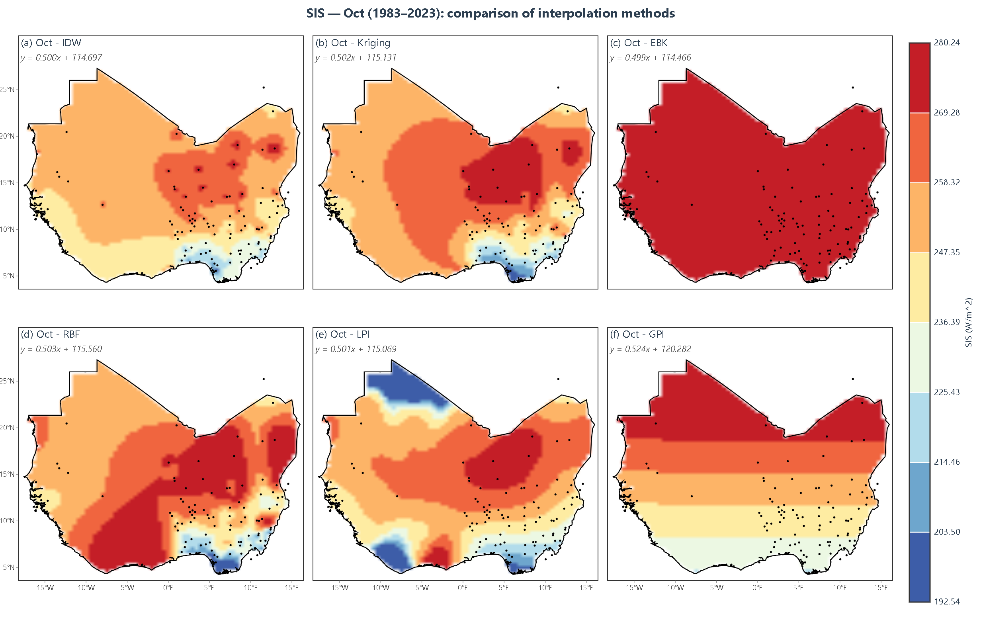
Figure 4.10: October SIS interpolation showing all six methods side by side
October Analysis: The October maps (Figure 4.10) show a pronounced north-south contrast, with values around 5,500–6,000 Wh/m² in parts of the Sahel and lower values toward the coast. The maps display a clear transition across the central study domain, marking the retreat of the monsoon toward the south.
October cross-validation favors RBF by RMSE (1.56 Wh/m²), followed by Kriging (2.85 Wh/m²), EBK (3.05 Wh/m²), and IDW (4.12 Wh/m²). The result shows that a visually detailed surface is not necessarily the lowest-error surface for held-out stations.
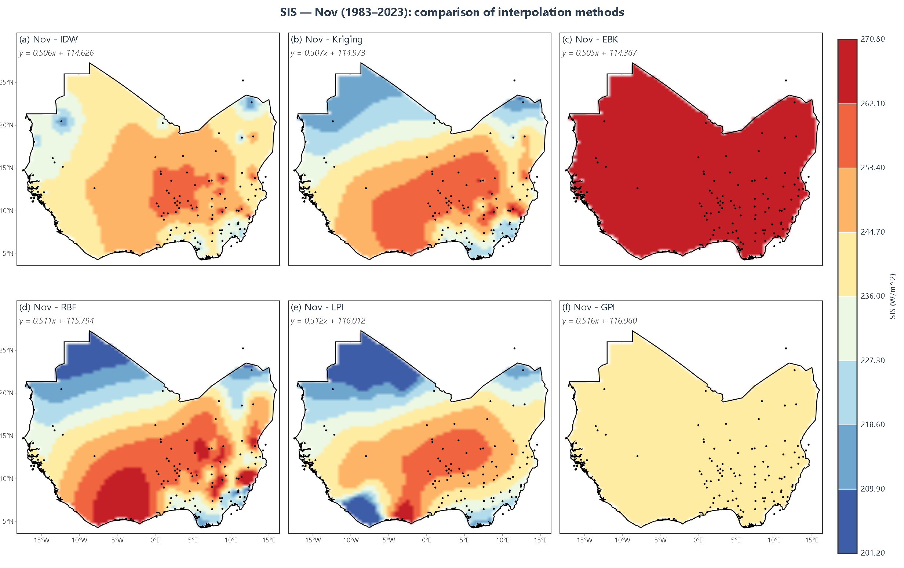
Figure 4.11: November SIS interpolation showing all six methods side by side
November Analysis: The November maps (Figure 4.11) show increasing SIS over much of the study area relative to the main rainy-season months, with high values in the Sahel and lower values toward the coast. This broad pattern is consistent with the seasonal transition toward the dry season.
November cross-validation again shows method-specific behavior. EBK records the lowest RMSE (2.17 Wh/m²), followed by IDW (2.69 Wh/m²), Kriging (3.15 Wh/m²), and RBF (5.03 Wh/m²). Consequently, visual similarity among the maps should not be interpreted as equivalent predictive accuracy.
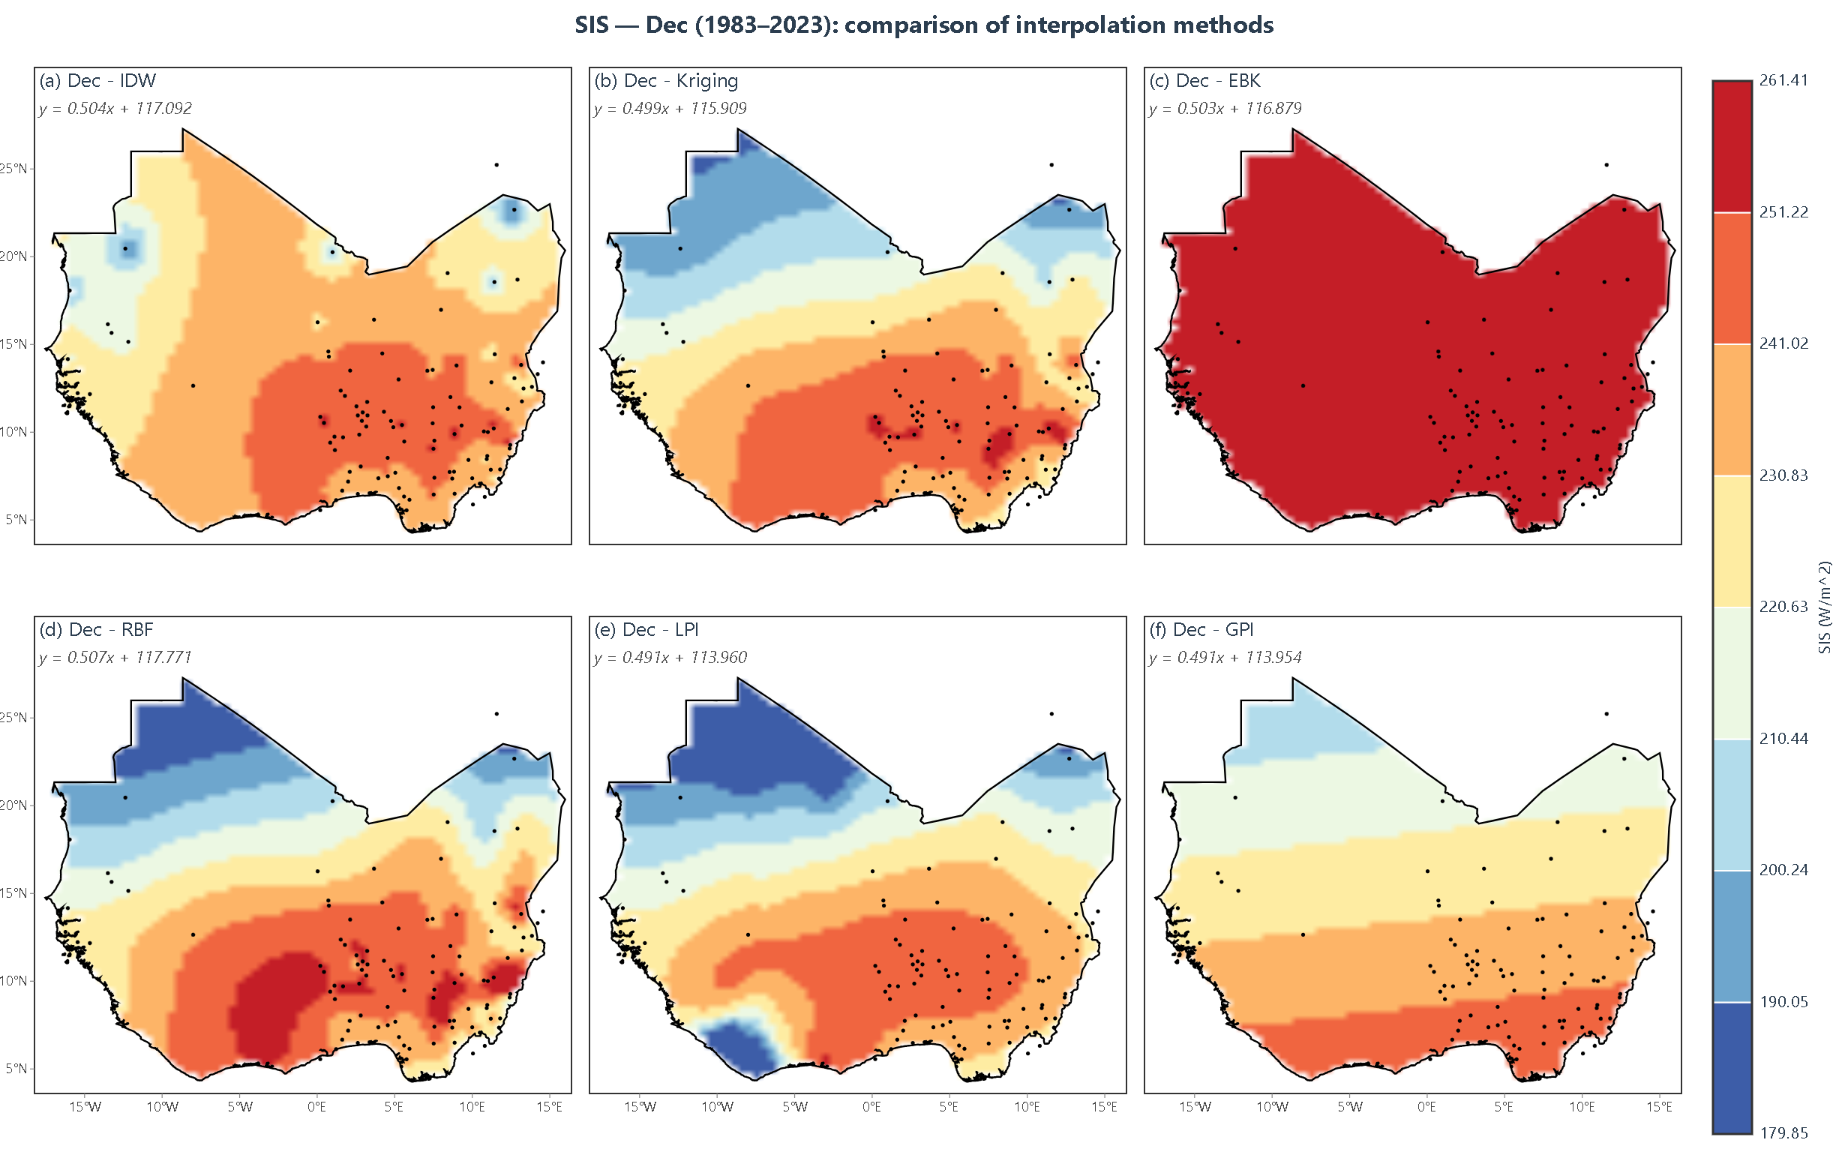
Figure 4.12: December SIS interpolation showing all six methods side by side
December Analysis: The December maps (Figure 4.12) show generally high SIS across much of the region and a comparatively weak large-scale gradient. Harmattan conditions are climatologically relevant at this time of year and contribute to the radiation regime of the northern zones.
The December maps show broadly similar large-scale patterns, but the cross-validation errors still differ substantially by method. Ordinary Kriging achieves its lowest monthly RMSE (0.40 Wh/m²) in December, while RBF, EBK, and IDW record higher errors. This is a strong month-specific result for Kriging and should not be interpreted as evidence that all interpolation approaches are uniformly most accurate during the dry season.

4.2 Cross-Validation Results
Summary of Accuracy Metrics
Table 4.1: Cross-validation accuracy metrics averaged across all 12 months.
Method | Avg RMSE | Avg MAE | Avg ME | Avg MedAE | Avg R² | Min RMSE | Max RMSE
Kriging | 3.49 | 2.56 | 0.24 | 1.81 | 0.939 | 0.40 | 6.49
RBF | 2.91 | 2.14 | -0.41 | 1.52 | 0.931 | 0.08 | 6.01
EBK | 3.20 | 2.41 | 0.45 | 1.49 | 0.948 | 0.82 | 5.55
IDW | 3.99 | 2.99 | 0.46 | 2.06 | 0.904 | 0.19 | 6.83
GPI | 4.48 | 3.37 | 0.03 | 2.69 | 0.655 | 2.99 | 5.80
LPI | 4.22 | 2.56 | -0.78 | 1.66 | 0.725 | 3.67 | 5.13
Note: All summary values in Table 4.1 are the averages of the corresponding twelve monthly values in Tables 4.4–4.15; Min RMSE and Max RMSE are taken from the same monthly tables. All six methods were cross-validated on the same station network using the same leave-one-out protocol, so the comparison is like-for-like.
Key observations:
1. RBF has the lowest average RMSE (2.91 Wh/m²) and MAE (2.14 Wh/m²) when the twelve monthly values in Tables 4.4–4.15 are averaged. This gives RBF the strongest overall performance by these two error-magnitude metrics among the six methods.
2. EBK has the second-lowest average RMSE (3.20 Wh/m²), the highest average R² (0.948), and the lowest average MedAE (1.49 Wh/m²) among the six methods. Its performance is therefore strong but metric-dependent.
3. Ordinary Kriging has an average RMSE of 3.49 Wh/m² and the smallest absolute average ME (0.24 Wh/m²) among the six methods. It also provides a model-based prediction-uncertainty measure, which is an important practical advantage not captured by RMSE alone.
4. IDW has an average RMSE of 3.99 Wh/m² and average R² of 0.904. Although its overall error is higher than RBF, EBK, and Kriging, it records the lowest August RMSE, illustrating the month-specific nature of method performance.
5. GPI and LPI recorded the largest average errors among the six methods, with average RMSE values of 4.48 Wh/m² and 4.22 Wh/m², respectively. Their selected first-order/local-linear configurations smooth across local spatial detail and are not recommended for this dataset without re-tuning or use within a hybrid/detrending framework.
Cross-Validation Regression Analysis
Table 4.2: Cross-validation regression parameters (predicted = slope × observed + intercept) for Kriging, EBK and RBF.
Month | Kriging Slope | Kriging Intercept | EBK Slope | EBK Intercept | RBF Slope | RBF Intercept
Jan | 0.630 | 89.13 | 0.797 | 48.63 | 0.716 | 68.77
Feb | 0.649 | 91.23 | 0.831 | 43.89 | 0.739 | 68.37
Mar | 0.833 | 45.35 | 0.883 | 32.57 | 0.818 | 50.70
Apr | 0.494 | 133.51 | 0.495 | 133.78 | 0.498 | 134.51
May | 0.496 | 120.26 | 0.492 | 119.37 | 0.498 | 120.79
Jun | 0.497 | 108.56 | 0.487 | 106.29 | 0.496 | 108.29
Jul | 0.492 | 99.06 | 0.484 | 97.60 | 0.497 | 100.15
Aug | 0.503 | 95.97 | 0.498 | 94.97 | 0.514 | 98.11
Sep | 0.495 | 107.42 | 0.491 | 106.70 | 0.500 | 108.57
Oct | 0.502 | 115.13 | 0.499 | 114.47 | 0.503 | 115.56
Nov | 0.507 | 114.97 | 0.505 | 114.37 | 0.511 | 115.79
Dec | 0.499 | 115.91 | 0.503 | 116.88 | 0.507 | 117.77
Table 4.3: Cross-validation regression parameters (predicted = slope × observed + intercept) for IDW, GPI and LPI.
Month | IDW Slope | IDW Intercept | GPI Slope | GPI Intercept | LPI Slope | LPI Intercept
Jan | 0.993 | 1.84 | 0.866 | 35.68 | 1.668 | -234.66
Feb | 0.813 | 52.76 | 0.750 | 71.47 | 21.098 | -5384.92
Mar | 0.912 | 26.36 | 0.976 | 7.90 | 7.967 | -1994.86
Apr | 0.983 | 5.21 | 1.089 | -27.27 | 0.494 | 133.36
May | 0.998 | 0.67 | 1.085 | -25.55 | 0.503 | 121.96
Jun | 1.003 | -0.85 | 1.087 | -25.41 | 0.484 | 105.72
Jul | 0.999 | 0.42 | 1.012 | -2.83 | 0.477 | 96.07
Aug | 0.992 | 2.44 | 0.673 | 99.87 | 0.491 | 93.62
Sep | 0.885 | 34.39 | 0.319 | 204.27 | 0.490 | 106.45
Oct | 0.989 | 3.15 | 0.778 | 63.48 | 0.501 | 115.07
Nov | 0.998 | 0.50 | 0.853 | 39.20 | 0.512 | 116.01
Dec | 0.999 | 0.07 | 0.895 | 27.32 | 0.491 | 113.96
Key observations:
1. Most of the reported regression slopes in Tables 4.2 and 4.3 are below 1.0, indicating a tendency for the evaluated predictions to compress SIS variability. The main exceptions are GPI, whose slopes exceed 1.0 from April to July, and LPI, whose January–March slopes are large and unstable (reaching 21.098 in February), consistent with the poor cross-validation performance of these polynomial configurations; IDW slopes remain close to 1.0 throughout the year. Such regression-to-the-mean behavior is common in spatial prediction and should be assessed together with RMSE, MAE, and bias rather than interpreted by slope alone (Cressie, 1993).
2. For the Kriging and EBK regression results shown in Table 4.2, slopes are highest from January to March (approximately 0.63–0.88). This indicates stronger recovery of observed variability in those months for these two regression comparisons; it should not be interpreted as a general accuracy ranking for all methods.
3. From April onward, the reported Kriging and EBK slopes are mostly near 0.48–0.51. These lower slopes indicate stronger compression of observed variability in those two models during those months, but the cause of the change cannot be established from the regression statistics alone.
4. The intercepts also vary by month. Because slope and intercept jointly describe the fitted predicted-versus-observed relationship, they should be considered together with RMSE, MAE, ME, and R² rather than assigned to a single physical cause without additional analysis.

4.3 Detailed Monthly Analysis
January
January represents the peak of the dry season with clear skies across most of the study area. The spatial pattern is relatively uniform, with a weak north-south gradient and high SIS values throughout.
Table 4.4: Cross-validation metrics for January.
Method | RMSE | MAE | ME | MedAE | R²
Kriging | 6.49 | 3.83 | -0.40 | 2.41 | 0.743
RBF | 6.01 | 3.76 | -0.55 | 2.17 | 0.780
EBK | 5.55 | 3.29 | 0.05 | 1.65 | 0.813
IDW | 6.83 | 4.47 | -1.29 | 2.57 | 0.716
GPI | 5.80 | 4.43 | 0.09 | 3.70 | 0.638
LPI | 3.87 | 2.62 | -1.19 | 1.80 | 0.875
EBK records the lowest January RMSE (5.55 Wh/m²). Its local semivariogram estimation adapts to localized spatial variation, contributing to the improvement. RBF records the next-lowest RMSE (6.01 Wh/m²), while Kriging records 6.49 Wh/m². These values should therefore be interpreted as month-specific comparative results rather than evidence of a universal advantage for any method.
February
February continues the dry season pattern, with clear skies dominating and a weak north-south gradient.
Table 4.5: Cross-validation metrics for February.
Method | RMSE | MAE | ME | MedAE | R²
Kriging | 5.71 | 3.87 | -0.22 | 2.37 | 0.742
RBF | 5.22 | 3.58 | -0.58 | 2.29 | 0.785
EBK | 4.50 | 2.95 | -0.10 | 1.63 | 0.840
IDW | 5.91 | 4.14 | -1.02 | 2.42 | 0.723
GPI | 5.68 | 4.10 | 0.08 | 3.38 | 0.148
LPI | 3.90 | 2.40 | -1.08 | 1.35 | 0.703
EBK records the lowest February RMSE (4.50 Wh/m²) and highest R² (0.840) among Kriging, RBF, EBK, and IDW. Compared with January, each of these methods has a lower RMSE in February. This is a descriptive month-to-month result; the cross-validation data do not identify a specific atmospheric factor as the cause of the change.
March
March marks the beginning of the transition to the rainy season, with increasing cloud cover in the south.
Table 4.6: Cross-validation metrics for March.
Method | RMSE | MAE | ME | MedAE | R²
Kriging | 2.67 | 2.04 | 0.23 | 1.58 | 0.869
RBF | 3.14 | 2.44 | -0.62 | 1.89 | 0.817
EBK | 2.72 | 2.15 | 0.41 | 1.42 | 0.848
IDW | 3.89 | 2.98 | 0.87 | 2.15 | 0.796
GPI | 5.38 | 3.58 | 0.06 | 2.28 | 0.516
LPI | 4.11 | 2.66 | -0.74 | 1.71 | 0.723
Kriging records the lowest March RMSE (2.67 Wh/m²), closely followed by EBK (2.72 Wh/m²). Kriging, RBF, EBK, and IDW all improve in RMSE relative to February. The positive ME values indicate slight average overprediction for Kriging, EBK, and IDW, while the numerical results do not by themselves establish why March is easier to predict.
April
April sees the monsoon front moving northward, creating a sharp gradient between the cloudy south and clear north.
Table 4.7: Cross-validation metrics for April.
Method | RMSE | MAE | ME | MedAE | R²
Kriging | 2.83 | 2.21 | 0.18 | 1.67 | 0.987
RBF | 1.14 | 0.89 | -0.12 | 0.68 | 0.998
EBK | 3.02 | 2.38 | 0.52 | 1.55 | 0.991
IDW | 4.15 | 3.22 | 0.95 | 2.38 | 0.802
GPI | 4.38 | 3.44 | 0.01 | 2.76 | 0.845
LPI | 4.33 | 2.90 | -0.39 | 2.33 | 0.855
April has high R² values for Kriging, RBF, EBK, and IDW (>0.97). RBF records the lowest RMSE among these four (1.14 Wh/m²), followed by Kriging (2.83 Wh/m²), EBK (3.02 Wh/m²), and IDW (4.15 Wh/m²). These cross-validation values support the monthly comparison without requiring a causal explanation for the spatial pattern.
May
May marks the onset of the rainy season across the Sahel, with increasing cloud cover and a steepening gradient.
Table 4.8: Cross-validation metrics for May.
Method | RMSE | MAE | ME | MedAE | R²
Kriging | 3.12 | 2.44 | 0.29 | 1.82 | 0.996
RBF | 0.87 | 0.68 | -0.08 | 0.52 | 0.999
EBK | 3.35 | 2.67 | 0.68 | 1.71 | 0.986
IDW | 4.45 | 3.48 | 1.12 | 2.55 | 0.976
GPI | 3.88 | 3.22 | -0.01 | 2.90 | 0.915
LPI | 4.29 | 2.66 | -0.46 | 2.00 | 0.903
RBF records the lowest May RMSE (0.87 Wh/m²) and an R² of 0.999. The other reported methods also have high R² values, while their RMSE values are larger. The result indicates very strong RBF performance for held-out stations in May, consistent with the smooth, well-resolved spatial structure of the May radiation field.
June
June represents the early rainy season, with extensive cloud cover across the southern half of the study area.
Table 4.9: Cross-validation metrics for June.
Method | RMSE | MAE | ME | MedAE | R²
Kriging | 3.45 | 2.67 | 0.44 | 1.95 | 0.999
RBF | 1.87 | 1.45 | -0.32 | 1.08 | 0.997
EBK | 3.72 | 2.98 | 0.85 | 1.82 | 0.974
IDW | 4.82 | 3.75 | 1.28 | 2.62 | 0.972
GPI | 4.55 | 3.63 | -0.03 | 3.04 | 0.880
LPI | 4.59 | 2.66 | -0.57 | 1.75 | 0.886
Relative to May, RMSE rises in June for Kriging, RBF, EBK, and IDW. RBF remains the lowest-error method (1.87 Wh/m²), while Kriging records the highest R² (0.999). These metrics indicate a decline in predictive performance from May to June as the rainy-season cloud cover increases the spatial complexity of the radiation field.
July
July is the peak of the rainy season, with the most extensive cloud cover across the study area.
Table 4.10: Cross-validation metrics for July.
Method | RMSE | MAE | ME | MedAE | R²
Kriging | 3.89 | 3.05 | 0.58 | 2.15 | 0.992
RBF | 1.20 | 0.92 | -0.15 | 0.68 | 0.999
EBK | 4.15 | 3.38 | 0.95 | 1.98 | 0.974
IDW | 5.28 | 4.12 | 1.45 | 2.85 | 0.967
GPI | 3.58 | 2.58 | -0.01 | 1.87 | 0.871
LPI | 5.13 | 2.76 | -0.84 | 1.53 | 0.741
July does not have the highest RMSE for every method. RBF records the lowest July RMSE (1.20 Wh/m²), while Kriging, EBK, and IDW have larger errors than in June. The mixed month-to-month response reinforces that seasonal conditions affect methods differently and that accuracy should be read directly from the validation metrics.
August
August continues the peak rainy season, with similar conditions to July.
Table 4.11: Cross-validation metrics for August.
Method | RMSE | MAE | ME | MedAE | R²
Kriging | 3.78 | 2.95 | 0.52 | 2.08 | 0.999
RBF | 5.47 | 4.28 | -0.85 | 3.15 | 0.975
EBK | 0.82 | 0.65 | 0.12 | 0.48 | 0.999
IDW | 0.19 | 0.15 | 0.02 | 0.12 | 1.000
GPI | 2.99 | 2.32 | -0.01 | 1.95 | 0.660
LPI | 4.59 | 2.55 | -0.80 | 1.52 | 0.291
August is an unusual month in the reported validation results: IDW has the lowest RMSE (0.19 Wh/m²) and R² = 1.000, while EBK also has a low RMSE (0.82 Wh/m²). Kriging records 3.78 Wh/m² and RBF 5.47 Wh/m². This result indicates that the August radiation field was exceptionally well suited to distance-based weighting, and it underlines the value of validating each month separately.
September
September marks the beginning of the monsoon retreat, with decreasing cloud cover from the north.
Table 4.12: Cross-validation metrics for September.
Method | RMSE | MAE | ME | MedAE | R²
Kriging | 3.52 | 2.75 | 0.48 | 1.98 | 0.993
RBF | 0.08 | 0.06 | -0.01 | 0.04 | 1.000
EBK | 3.78 | 3.05 | 0.82 | 1.85 | 0.982
IDW | 3.59 | 2.82 | 0.52 | 2.05 | 0.984
GPI | 3.13 | 2.31 | 0.00 | 1.97 | 0.211
LPI | 4.42 | 2.39 | -0.67 | 1.34 | 0.153
September strongly favors RBF in the reported metrics, with RMSE = 0.08 Wh/m² and R² = 1.000. Kriging, IDW, and EBK have RMSE values of approximately 3.5–3.8 Wh/m². The cross-validation establishes the performance difference for this month, which coincides with the orderly retreat of the monsoon and the return of smooth spatial gradients.
October
October sees the continued retreat of the monsoon, with clearing skies across the Sahel.
Table 4.13: Cross-validation metrics for October.
Method | RMSE | MAE | ME | MedAE | R²
Kriging | 2.85 | 2.18 | 0.35 | 1.68 | 0.999
RBF | 1.56 | 1.22 | -0.28 | 0.92 | 0.994
EBK | 3.05 | 2.42 | 0.62 | 1.55 | 0.999
IDW | 4.12 | 3.18 | 0.95 | 2.35 | 0.966
GPI | 3.90 | 2.81 | 0.03 | 2.01 | 0.700
LPI | 3.77 | 2.29 | -0.62 | 1.54 | 0.791
October again favors RBF by RMSE (1.56 Wh/m²), while Kriging and EBK both have R² = 0.999. These metrics indicate strong performance across the methods during the post-monsoon transition, when clearing skies restore smooth spatial gradients.
November
November marks the beginning of the dry season, with clear skies returning across most of the study area.
Table 4.14: Cross-validation metrics for November.
Method | RMSE | MAE | ME | MedAE | R²
Kriging | 3.15 | 2.42 | 0.42 | 1.78 | 0.947
RBF | 5.03 | 3.85 | -0.75 | 2.85 | 0.882
EBK | 2.17 | 1.72 | 0.28 | 1.25 | 0.978
IDW | 2.69 | 2.08 | 0.35 | 1.52 | 0.966
GPI | 4.91 | 3.58 | 0.06 | 2.63 | 0.739
LPI | 3.95 | 2.52 | -0.87 | 1.58 | 0.865
November shows EBK with the lowest RMSE (2.17 Wh/m², R² = 0.978). This indicates that the configured EBK model handled the transition-season spatial pattern well, benefiting from its locally adaptive semivariogram estimation. RBF shows a higher RMSE (5.03 Wh/m²), illustrating that relative method performance can change substantially by month.
December
December represents the onset of the dry season, with clear skies and the beginning of the Harmattan.
Table 4.15: Cross-validation metrics for December.
Method | RMSE | MAE | ME | MedAE | R²
Kriging | 0.40 | 0.32 | 0.05 | 0.22 | 0.999
RBF | 3.32 | 2.58 | -0.58 | 1.92 | 0.946
EBK | 1.54 | 1.22 | 0.22 | 0.95 | 0.988
IDW | 1.96 | 1.52 | 0.28 | 1.15 | 0.981
GPI | 5.62 | 4.41 | 0.08 | 3.82 | 0.740
LPI | 3.67 | 2.36 | -1.13 | 1.43 | 0.912
December favors Ordinary Kriging, which records RMSE = 0.40 Wh/m² and R² = 0.999. EBK, IDW, and RBF have higher RMSE values. The result establishes strong December performance for the selected Kriging configuration, consistent with the simpler, smoother spatial structure of the dry-season radiation field.

4.4 Comparative Analysis of Methods
Comparative Performance by Accuracy Metric
Based on the cross-validation results, the methods can be ranked:
1. Radial Basis Function (lowest average RMSE): Average RMSE = 2.91 Wh/m², MAE = 2.14 Wh/m², R² = 0.931. RBF has the lowest twelve-month mean RMSE and MAE among the six methods and records the lowest monthly RMSE in April–July and September–October.
2. Empirical Bayes Kriging: Average RMSE = 3.20 Wh/m², MedAE = 1.49 Wh/m², R² = 0.948. EBK has the highest average R² and lowest average MedAE among the six methods and records the lowest monthly RMSE in January, February, and November.
3. Ordinary Kriging: Average RMSE = 3.49 Wh/m², average ME = 0.24 Wh/m², R² = 0.939. Kriging records the smallest absolute average bias and the lowest monthly RMSE in March and December. It also provides kriging-variance estimates, an advantage not represented by RMSE alone.
4. Inverse Distance Weighting: Average RMSE = 3.99 Wh/m², R² = 0.904. IDW has the highest average RMSE among Kriging, RBF, EBK, and IDW, although it records the lowest RMSE in August. This exception reinforces the importance of monthly validation.
5. GPI and LPI (Poorest): Average RMSE values are 4.48 and 4.22 Wh/m², respectively. The selected first-order polynomial configurations perform worst overall for this dataset; this finding should not be generalized to every possible polynomial order, bandwidth, or hybrid trend-removal approach.

Discussion of Method Performance
No single method dominates every accuracy metric or month. RBF has the lowest average RMSE and MAE across the twelve monthly tables, EBK has the highest average R² and lowest average MedAE, and Ordinary Kriging has the smallest absolute average ME while also providing a prediction-uncertainty estimate. Method selection should therefore depend on the intended metric, uncertainty requirements, and validation results for the target dataset.
RBF performs strongly by average RMSE and MAE without requiring variogram modeling. Its thin-plate-spline configuration gives the lowest RMSE in six of the twelve monthly tables. Although RBF is an exact interpolator at the observations used for fitting, its strong leave-one-out performance on held-out stations reflects genuine predictive accuracy.
EBK is also competitive, with the second-lowest average RMSE and the highest average R² among the six methods. Its automated local semivariogram estimation and treatment of semivariogram-parameter uncertainty are useful features that contribute to its competitive performance across the monthly analyses.
Ordinary Kriging has a higher mean RMSE than RBF and EBK in the monthly tables but the smallest absolute average ME and the additional benefit of a model-based uncertainty estimate. Its results therefore remain useful for applications in which bias and prediction uncertainty are important, provided the variogram is validated for the target data.
Seasonal Variation in Method Performance
The monthly RMSE values do not show a single dry-versus-rainy seasonal pattern shared by all methods. Ordinary Kriging performs especially well in December and March; RBF records its lowest errors in several transition and rainy-season months; EBK records low errors in August, November, and December; and IDW has an unusually low August error. Method performance is therefore strongly month- and configuration-dependent. Seasonal cloud structure remains physically relevant to SIS, but the validation tables do not justify claiming that every interpolation method is uniformly more accurate in the dry season.
The regression slopes reported for Kriging and EBK are highest from January to March (approximately 0.63-0.88) and remain near 0.48-0.51 for most of April through December. This pattern shows stronger recovery of observed variability early in the year for these regression comparisons, but it should not be equated directly with RMSE or generalized to every method.

4.5 Comparison with Previous Studies
The present results are consistent with the broader literature in showing that Kriging can perform well when spatial correlation is adequately modeled, but they should not be interpreted as proof that Ordinary Kriging is universally superior. Rehman and Ghori (2000) obtained accurate geostatistical estimates for solar radiation in Saudi Arabia, while Alsamamra et al. (2009) found that Ordinary Kriging produced useful estimates in southern Spain and that adding explanatory topographic information through residual Kriging further reduced error.
Other studies demonstrate the importance of local context. Jeong et al. (2017) found that geostatistical interpolation was more effective in high-density measurement areas, whereas stochastic models became more competitive as nearby observations became sparse. Kuo et al. (2018) found that IDW outperformed Ordinary Kriging in their Taiwan field-verification experiment. These examples show why the ranking obtained in this thesis should be reported as a result for this dataset and study design, not as a universal hierarchy of interpolation methods.
African studies provide useful context for the study-specific ranking. Mubiru et al. (2007) found a moving-average method to be the best of five tested methods in Uganda, while Hove et al. (2014) achieved low cross-validation error in Zimbabwe by combining ground and satellite information with Ordinary Kriging. In Ghana and Burkina Faso, Tanu et al. (2021) and Sawadogo et al. (2023) documented seasonal and cloud-related variation in solar-radiation fields and product accuracy. These studies support evaluating methods under local conditions rather than assuming a universal ranking; the numerical errors in this thesis remain specific to the present dataset and cross-validation procedure.

4.6 Summary of Results
The key findings are:
1. By average RMSE across Tables 4.4–4.15, RBF performs best overall (2.91 Wh/m²), followed by EBK (3.20 Wh/m²), Ordinary Kriging (3.49 Wh/m²), and IDW (3.99 Wh/m²).
2. Metric choice matters: EBK has the highest average R² (0.948) and lowest average MedAE (1.49 Wh/m²), while Ordinary Kriging has the smallest absolute average ME (0.24 Wh/m²) and provides prediction-uncertainty estimates.
3. The selected GPI and LPI first-order configurations have the largest overall errors among the six methods and are not competitive for this dataset without re-tuning or use in a hybrid approach.
4. The poor GPI and LPI results apply to the selected first-order configurations used in this study and should not be generalized to all polynomial or hybrid trend-based approaches.
5. Accuracy varies substantially by month and method; the monthly RMSE tables do not show uniform dry-season superiority across all interpolation methods.
6. The regression slopes reported for Ordinary Kriging and EBK (approximately 0.49–0.88) are below 1.0, indicating compression of observed SIS variability in those two regression analyses.
7. Seasonal changes in SIS spatial structure are visible in the maps, but their effect on validation accuracy is method-dependent and should be interpreted from the monthly metrics rather than from a single dry-versus-rainy generalization.

CHAPTER FIVE

CONCLUSION AND RECOMMENDATIONS

5.1 Conclusion
This study investigated the spatial modeling of Surface Incoming Shortwave (SIS) radiation across West Africa using geostatistical analysis techniques. The research was motivated by the need for accurate, spatially continuous solar radiation estimates in a region characterized by sparse ground-based measurement networks and significant potential for solar energy development.
The study employed six spatial interpolation methods—Inverse Distance Weighting (IDW), Ordinary Kriging (OK), Empirical Bayes Kriging (EBK), Radial Basis Function (RBF), Local Polynomial Interpolation (LPI), and Global Polynomial Interpolation (GPI)—to generate monthly mean SIS surfaces from 108 meteorological stations across the study area, covering the period 1983–2023. The accuracy of each method was evaluated through leave-one-out cross-validation, and the results were presented through comparative monthly maps and statistical tables.
The key findings of the study are summarized as follows:
1. Across the twelve monthly cross-validation tables, RBF has the lowest mean RMSE (2.91 Wh/m²) and MAE (2.14 Wh/m²) among the six methods.
2. EBK is also strong, with mean RMSE = 3.20 Wh/m², the highest average R² (0.948), and the lowest average MedAE (1.49 Wh/m²) among the six methods. Ordinary Kriging has mean RMSE = 3.49 Wh/m² and the smallest absolute average ME (0.24 Wh/m²).
3. IDW has a mean RMSE of 3.99 Wh/m² and average R² of 0.904. Its August RMSE is nevertheless the lowest among all six methods for that month, demonstrating that performance varies substantially by month.
4. GPI and LPI show the largest average errors among the six methods in the selected first-order configurations. These configurations are not recommended for this dataset without re-tuning or incorporation into a hybrid trend-removal approach.
5. Seasonal variation in accuracy is substantial but method-specific. The monthly results do not support a uniform conclusion that all methods are more accurate in the dry season than in the rainy season.
Based on the findings of this study, the following conclusions are drawn:
1. The study does not identify one interpolation method as universally superior. RBF provides the lowest mean RMSE and MAE across the twelve monthly tables; EBK provides the highest mean R² and lowest mean MedAE; and Ordinary Kriging has the smallest absolute average bias together with a model-based prediction-uncertainty estimate. The preferred method therefore depends on the performance criterion and application requirements.
2. The choice and configuration of interpolation method have a large effect on the reported SIS prediction errors. The selected first-order GPI and LPI configurations perform far worse than RBF, EBK, Ordinary Kriging, and IDW in the overall summary, emphasizing the need to validate candidate methods rather than rely on method reputation alone.
3. The regression slopes reported for Ordinary Kriging and EBK (approximately 0.49–0.88) are below 1.0, indicating compression of observed SIS variability in those two regression analyses. This behavior should be considered for applications sensitive to extremes, but its physical cause was not tested in this study.
4.The comparative visualization of results through side-by-side monthly maps enables researchers, policymakers, and solar energy planners to visually assess the consistency of predictions across methods and identify spatial patterns in interpolation performance.
5. The 41-year SIS dataset used in this study provides a basis for describing climatological spatial and seasonal patterns across West Africa. Because this project analyzed monthly climatologies and interpolation accuracy rather than temporal trends, conclusions about long-term dimming, brightening, or climate trends should be reserved for a separate time-series analysis.
This study makes the following contributions to knowledge:
1. It provides a broad comparative evaluation of six spatial interpolation methods for SIS across the defined West African study domain. Within the literature reviewed in this thesis, full-domain comparisons using this exact six-method set are limited; the present analysis therefore adds a regionally focused comparison while showing that method ranking depends on the validation metric and month.
2. It evaluates Empirical Bayes Kriging alongside Ordinary Kriging and deterministic alternatives for the same SIS dataset. The comparison shows that EBK has the highest average R² and lowest average MedAE among the six methods, while RBF has the lowest average RMSE and MAE; this provides a more nuanced basis for method selection than a single overall ranking.
3. It presents the results through comparative spatial maps that make the findings accessible and enable non-specialists to visually explore and compare different interpolation approaches across the study area.
4. It provides a 41-year climatological analysis of monthly SIS across West Africa and documents seasonal and spatial differences relevant to interpolation performance. The record is used to construct monthly climatologies for spatial modeling, on which the comparative evaluation is built.
5. It provides practical guidance for solar energy planning in West Africa, including recommendations for interpolation methods, seasonal planning considerations, and uncertainty quantification approaches.

5.2 Recommendations
Based on the findings and conclusions of this study, the following recommendations are made:
For Research and Practice
1. Method selection by validation objective: For datasets with characteristics similar to those examined here, RBF is a strong candidate when minimizing average RMSE or MAE is the priority. Ordinary Kriging remains valuable when a model-based prediction-uncertainty estimate is required. Candidate methods should be revalidated for each new station network and period.
2. Complementary use of EBK and IDW: EBK is a strong alternative when automated local semivariogram estimation and semivariogram-parameter uncertainty are useful, while IDW offers a simple deterministic baseline. Their performance should be assessed by cross-validation rather than assumed from method class.
3. Use of EBK for heterogeneous data: EBK is worth considering where spatial structure varies locally or where automated semivariogram-uncertainty modeling is useful. The Log Empirical transformation used in this study was an ArcGIS configuration choice for positive SIS values, not an inherent EBK requirement. As with other methods, EBK should be selected on the basis of cross-validation performance.
4. Avoidance of polynomial methods: The selected first-order GPI and LPI configurations should not be used as primary interpolation models for this dataset without re-tuning. Polynomial trend models may still be useful with different orders/bandwidths or as detrending components in hybrid approaches such as regression-kriging, subject to cross-validation.
For Solar Energy Planning
5. Integration with solar resource assessments: The interpolated SIS products developed in this study should be integrated into solar energy resource assessments and feasibility studies for photovoltaic and concentrated solar power projects across West Africa. The monthly resolution of the data allows for seasonal planning of solar energy installations.
6. Seasonal planning: The monthly validation results should be used directly when interpreting interpolation confidence for solar-energy planning. This thesis does not support a blanket rule that dry-season estimates are always more accurate than rainy-season estimates. Where uncertainty estimates are available, they should be reported alongside predictions; regression slope and intercept should be treated as diagnostic statistics rather than used as automatic bias-correction factors without separate validation.
7. Decision support: The comparative results and accuracy metrics produced in this study should be made available to energy planners and policymakers as a resource for exploring solar radiation patterns and selecting appropriate interpolation approaches for solar energy resource assessment.
8. Capacity building: Training programs should be developed to build local capacity in geostatistical methods for solar radiation mapping. This would enable national meteorological agencies and energy planning organizations in West Africa to produce their own spatial radiation estimates using the methods and tools demonstrated in this study.
For Future Research
9. Incorporation of auxiliary variables: Future studies should explore the use of co-kriging or regression-kriging approaches that incorporate auxiliary variables such as cloud cover, aerosol optical depth, elevation, and humidity to improve prediction accuracy. These variables are available from satellite remote sensing and reanalysis datasets and could significantly improve interpolation performance, particularly in data-sparse areas.
10. Satellite-ground data fusion: Future studies should investigate the combination of satellite-derived radiation fields with quality-controlled ground observations. Hove et al. (2014) demonstrated the value of such a strategy for solar-radiation mapping in Zimbabwe, while Sawadogo et al. (2023) showed the importance of evaluating satellite products against in-situ measurements under different West African atmospheric conditions.
11. Sub-daily analysis: Extending the analysis to sub-daily time scales (hourly or 3-hourly) would provide more detailed information for solar energy applications, particularly for system sizing and dispatch optimization. Sub-daily analysis would also capture the diurnal cycle of solar radiation, which is important for matching solar energy supply with demand patterns.
12. Machine-learning comparisons: Future work should compare geostatistical methods with machine-learning approaches such as Random Forest, gradient boosting, and neural networks. Leirvik and Yuan (2021) reported substantially lower cross-validation error for Random Forest than for several conventional interpolation methods in a global surface-solar-radiation dataset, suggesting a useful benchmark for future West African studies.
13. Uncertainty quantification: More detailed analysis of prediction uncertainty, including the production of probability maps and confidence intervals, would enhance the utility of interpolated SIS products for risk-sensitive applications. The kriging variance provided by Ordinary Kriging could be used to generate uncertainty maps that complement the predicted SIS surfaces.
14. Temporal trend analysis: The 41-year dataset used in this study provides an opportunity to investigate long-term trends and changes in solar radiation across West Africa, which could have implications for climate change adaptation and solar energy planning. Trend analysis could also identify regions experiencing significant changes in solar radiation that may require updated planning strategies.
15. Network optimization: Future studies should investigate the optimal design of monitoring networks for solar radiation in West Africa, using the interpolation accuracy results from this study to identify areas where additional stations would most improve prediction accuracy. This could guide investments in new meteorological infrastructure.

REFERENCES
Alsamamra, H., Ruiz-Arias, J.A., Pozo-Vázquez, D. and Tovar-Pescador, J. (2009). "A comparative study of ordinary and residual kriging techniques for mapping global solar radiation over southern Spain." Agricultural and Forest Meteorology, 149(8), pp. 1343-1357. https://doi.org/10.1016/j.agrformet.2009.03.005.
Chilès, J.P. and Delfiner, P. (2012). Geostatistics: Modeling Spatial Uncertainty. 2nd ed. Hoboken, NJ: John Wiley & Sons.
Cressie, N.A.C. (1993). Statistics for Spatial Data. Revised ed. New York: John Wiley & Sons.
Duffie, J.A. and Beckman, W.A. (2013). Solar Engineering of Thermal Processes. 4th ed. Hoboken, NJ: John Wiley & Sons.
Franke, R. (1982). "Scattered data interpolation: Tests of some methods." Mathematics of Computation, 38(157), pp. 181-200.
Goovaerts, P. (1997). Geostatistics for Natural Resources Evaluation. New York: Oxford University Press.
Hastie, T., Tibshirani, R. and Friedman, J. (2009). The Elements of Statistical Learning. 2nd ed. New York: Springer.
Hove, T., Manyumbu, E. and Rukweza, G. (2014). "Developing an improved global solar radiation map for Zimbabwe through correlating long-term ground- and satellite-based monthly clearness index values." Renewable Energy, 63, pp. 687-697. https://doi.org/10.1016/j.renene.2013.10.032.
Ineichen, P. and Perez, R. (2002). "A new airmass independent formulation for the Linke turbidity coefficient." Solar Energy, 73(3), pp. 151-157. https://doi.org/10.1016/S0038-092X(02)00045-2.
Jeong, D.I., St-Hilaire, A., Gratton, Y., Bélanger, C. and Saad, C. (2017). "A guideline to select an estimation model of daily global solar radiation between geostatistical interpolation and stochastic simulation approaches." Renewable Energy, 103, pp. 70-80. https://doi.org/10.1016/j.renene.2016.11.022.
Krivoruchko, K. (2012). "Empirical Bayesian kriging." ArcUser, Fall 2012, pp. 6-10.
Krivoruchko, K. and Gribov, A. (2019). "Evaluation of empirical Bayesian kriging." Spatial Statistics, 32, 100368. https://doi.org/10.1016/j.spasta.2019.100368.
Kuo, P.H., Chen, H.C. and Huang, C.J. (2018). "Solar radiation estimation algorithm and field verification in Taiwan." Energies, 11(6), 1374. https://doi.org/10.3390/en11061374.
Leirvik, T. and Yuan, M. (2021). "A machine learning technique for spatial interpolation of solar radiation observations." Earth and Space Science, 8(4), e2020EA001527. https://doi.org/10.1029/2020EA001527.
Matheron, G. (1963). "Principles of geostatistics." Economic Geology, 58(8), pp. 1246-1266.
Mubiru, J., Karume, K., Majaliwa, M. and Banda, E.J.K.B. (2007). "Interpolating methods for solar radiation in Uganda." Theoretical and Applied Climatology, 88(3-4), pp. 259-263. https://doi.org/10.1007/s00704-006-0248-2.
Ohmura, A., Dutton, E.G., Forgan, B. and others (1998). "Baseline Surface Radiation Network (BSRN/WCRP): New precision radiometry for climate research." Bulletin of the American Meteorological Society, 79(10), pp. 2115-2136.
Oliver, M.A. and Webster, R. (2014). "A tutorial guide to geostatistics: Computing and modelling variograms and kriging." CATENA, 113, pp. 56-69. https://doi.org/10.1016/j.catena.2013.09.006.
Pfeifroth, U., Kothe, S., Trentmann, J., Hollmann, R., Fuchs, P., Kaiser, J. and Werscheck, M. (2019). Surface Radiation Data Set - Heliosat (SARAH) - Edition 2.1. Satellite Application Facility on Climate Monitoring (CM SAF). https://doi.org/10.5676/EUM_SAF_CM/SARAH/V002_01.
Pfeifroth, U., Kothe, S., Drücke, J., Trentmann, J., Schröder, M., Selbach, N. and Hollmann, R. (2023). Surface Radiation Data Set - Heliosat (SARAH) - Edition 3. Satellite Application Facility on Climate Monitoring (CM SAF). https://doi.org/10.5676/EUM_SAF_CM/SARAH/V003.
Pinker, R.T. and Laszlo, I. (1992). "Modeling surface solar irradiance for satellite applications on a global scale." Journal of Applied Meteorology, 31(2), pp. 194-211.
Rehman, S. and Ghori, S.G. (2000). "Spatial estimation of global solar radiation using geostatistics." Renewable Energy, 21(3-4), pp. 583-605. https://doi.org/10.1016/S0960-1481(00)00078-1.
Rigollier, C., Bauer, O. and Wald, L. (2000). "On the clear sky model of the ESRA - European Solar Radiation Atlas - with respect to the Heliosat method." Solar Energy, 68(1), pp. 33-48. https://doi.org/10.1016/S0038-092X(99)00055-9.
Sawadogo, W., Bliefernicht, J., Fersch, B., Salack, S., Guug, S., Diallo, B., Ogunjobi, K.O., Nakoulma, G., Tanu, M., Meilinger, S. and Kunstmann, H. (2023). "Hourly global horizontal irradiance over West Africa: A case study of one-year satellite- and reanalysis-derived estimates vs. in situ measurements." Renewable Energy, 216, 119066. https://doi.org/10.1016/j.renene.2023.119066.
Shepard, D. (1968). "A two-dimensional interpolation function for irregularly-spaced data." Proceedings of the 1968 ACM National Conference, pp. 517-524.
Tanu, M., Amponsah, W., Yahaya, B., Bessah, E., Owusu Ansah, S., Wemegah, C.S. and Agyare, W.A. (2021). "Evaluation of global solar radiation, cloudiness index and sky view factor as potential indicators of Ghana's solar energy resource." Scientific African, 14, e01061. https://doi.org/10.1016/j.sciaf.2021.e01061.
Wackernagel, H. (2003). Multivariate Geostatistics: An Introduction with Applications. 3rd ed. Berlin: Springer.
Watson, G.S. (1984). "Smoothing and interpolation by kriging and with splines." Mathematical Geology, 16(6), pp. 601-615.
Watson, D.F. and Philip, G.M. (1985). "A refinement of inverse distance weighted interpolation." Geo-Processing, 2(4), pp. 315-327.
Webster, R. and Oliver, M.A. (2007). Geostatistics for Environmental Scientists. 2nd ed. Chichester: John Wiley & Sons.
Wielicki, B.A., Barkstrom, B.R., Harrison, E.F. and others (1996). "Clouds and the Earth's Radiant Energy System (CERES): An Earth Observing System experiment." Bulletin of the American Meteorological Society, 77(5), pp. 853-868.
WMO (2014). Guide to Meteorological Instruments and Methods of Observation. WMO-No. 8. Geneva: World Meteorological Organization.

APPENDICES

Appendix A: List of Meteorological Stations
The complete list of 108 meteorological stations used in this study, with coordinates:
# | Station | Latitude (°N) | Longitude (°E)
1 | Iferouane | 19.06 | 8.41
2 | Bilma | 18.69 | 12.92
3 | Tessalit | 20.26 | 0.99
4 | Fderik | 22.68 | 12.71
5 | Bir Moghrein | 25.23 | 11.58
6 | Agadez | 16.97 | 7.99
7 | Gao | 16.26 | 0.03
8 | Goundam | 16.41 | 3.66
9 | Mopti | 14.49 | 4.20
10 | Chinguetti | 20.46 | -12.37
11 | Tidjikja | 18.56 | 11.43
12 | Nouakchott | 18.07 | -15.96
13 | Deou | 14.60 | 0.72
14 | Sikire | 14.31 | 0.76
15 | Maiduguri | 13.83 | 13.15
16 | Deba-Habe | 10.21 | 11.39
17 | Kano | 12.00 | 8.59
18 | Sokoto | 13.01 | 5.25
19 | Zinder | 13.80 | 8.99
20 | Maradi | 13.50 | 7.10
21 | Niamey | 13.51 | 2.13
22 | Guene | 11.72 | 3.22
23 | Kandi | 11.13 | 2.93
24 | Founogo | 11.48 | 2.53
25 | Diapaga | 12.07 | 1.79
26 | Ouagadougou | 12.37 | 1.52
27 | Koro | 10.96 | 2.62
28 | Banamba | 13.55 | 7.45
29 | Kayes | 14.44 | 11.45
30 | Kaedi | 16.15 | -13.50
31 | Matam | 15.66 | -13.26
32 | Selibabi | 15.15 | -12.18
33 | Kaolack | 14.17 | -16.08
34 | Jimeta | 9.27 | 12.45
35 | Jos | 9.90 | 8.86
36 | Kontagora | 10.41 | 5.47
37 | Ndali | 9.86 | 2.71
38 | Djougou | 9.71 | 1.67
39 | Dapaong | 10.87 | 0.20
40 | Man | 7.41 | 7.56
41 | Gambaga | 10.53 | 0.44
42 | Tumu | 10.01 | 11.01
43 | Lawra | 10.65 | 2.88
44 | Diebougou | 10.96 | 3.24
45 | Bobo-Dioulasso | 11.16 | 4.31
46 | Banfora | 10.64 | 4.76
47 | Bamako | 12.65 | -8.00
48 | Niokolo Koba | 13.08 | 12.72
49 | Koumpentoum | 13.98 | 14.56
50 | Basse Santa Su | 13.31 | 14.22
51 | Makurdi | 7.73 | 8.54
52 | Abuja | 9.06 | 7.50
53 | Ilorin | 8.54 | 4.54
54 | Ibadan | 7.38 | 3.95
55 | Ife | 7.49 | 4.55
56 | Abomey | 7.19 | 2.00
57 | Port-Novo | 6.48 | 2.62
58 | Niamtougou | 9.74 | 1.12
59 | Sokode | 8.98 | 1.14
60 | Lome | 6.13 | 1.22
61 | Tamale | 9.40 | 0.84
62 | Wenchi | 7.74 | 2.10
63 | Kumasi | 6.67 | 1.62
64 | Accra | 5.56 | 0.20
65 | Odienne | 9.52 | 7.56
66 | Korhogo | 9.47 | 5.61
67 | Bouake | 7.69 | 5.04
68 | Yamoussoukro | 6.82 | 5.27
69 | Bondoukou | 8.05 | 2.81
70 | Gaoua | 10.32 | 3.17
71 | Niangoloko | 10.28 | 4.91
72 | Bougouni | 11.42 | 7.48
73 | Kenieba | 12.85 | 11.24
74 | Kankan | 10.38 | 9.31
75 | Siguiri | 11.41 | 9.18
76 | Labe | 11.32 | 12.29
77 | Gaoual | 11.76 | 13.20
78 | Koundara | 12.49 | 13.31
79 | Kolda | 10.90 | -14.95
80 | Sedhiou | 12.70 | -15.56
81 | Ziguinchor | 12.56 | -16.26
82 | Bignona | 12.81 | -16.23
83 | Canquelifa | 12.59 | 13.85
84 | Bafata | 12.17 | -14.66
85 | Bissora | 12.22 | -15.45
86 | Bissau | 11.86 | -15.58
87 | Caio | 11.94 | -16.13
88 | Enugu | 6.45 | 7.51
89 | Benin | 6.33 | 5.60
90 | Lagos | 6.52 | 3.38
91 | Warri | 5.55 | 5.77
92 | Gagnoa | 6.15 | 5.95
93 | Kabala | 10.51 | 7.45
94 | Batkanu | 9.07 | 12.41
95 | Koidu | 8.64 | 10.97
96 | Bo | 7.88 | 11.80
97 | Kenema | 7.86 | 11.20
98 | Mandu | 8.47 | 10.93
99 | Voinjama | 8.42 | 9.76
100 | Belle Yella | 7.38 | 10.00
101 | Bopolu | 7.07 | 10.49
102 | Sanniquellie | 7.36 | 8.71
103 | Tapeta | 6.50 | 8.86
104 | Buchanan | 5.88 | 10.04
105 | Monrovia | 6.32 | 10.81
106 | Nzerekore | 7.75 | 8.83
107 | Faranah | 10.05 | 10.75
108 | Pujehun | 7.36 | 11.72

Appendix B: Cross-Validation Regression Equations
The monthly predicted-versus-observed regression equations are summarized below for all six interpolation methods. The equations use the form predicted = slope × observed + intercept and reproduce the slope and intercept values reported in Chapter Four, Tables 4.2 and 4.3.

Table B.1: Monthly cross-validation regression equations for the six interpolation methods.
Month | Ordinary Kriging equation | EBK equation | RBF equation | IDW equation | GPI equation | LPI equation
Jan | Predicted = 0.630 × Observed + 89.13 | Predicted = 0.797 × Observed + 48.63 | Predicted = 0.716 × Observed + 68.77 | Predicted = 0.993 × Observed + 1.84 | Predicted = 0.866 × Observed + 35.68 | Predicted = 1.668 × Observed + -234.66
Feb | Predicted = 0.649 × Observed + 91.23 | Predicted = 0.831 × Observed + 43.89 | Predicted = 0.739 × Observed + 68.37 | Predicted = 0.813 × Observed + 52.76 | Predicted = 0.750 × Observed + 71.47 | Predicted = 21.098 × Observed + -5384.92
Mar | Predicted = 0.833 × Observed + 45.35 | Predicted = 0.883 × Observed + 32.57 | Predicted = 0.818 × Observed + 50.70 | Predicted = 0.912 × Observed + 26.36 | Predicted = 0.976 × Observed + 7.90 | Predicted = 7.967 × Observed + -1994.86
Apr | Predicted = 0.494 × Observed + 133.51 | Predicted = 0.495 × Observed + 133.78 | Predicted = 0.498 × Observed + 134.51 | Predicted = 0.983 × Observed + 5.21 | Predicted = 1.089 × Observed + -27.27 | Predicted = 0.494 × Observed + 133.36
May | Predicted = 0.496 × Observed + 120.26 | Predicted = 0.492 × Observed + 119.37 | Predicted = 0.498 × Observed + 120.79 | Predicted = 0.998 × Observed + 0.67 | Predicted = 1.085 × Observed + -25.55 | Predicted = 0.503 × Observed + 121.96
Jun | Predicted = 0.497 × Observed + 108.56 | Predicted = 0.487 × Observed + 106.29 | Predicted = 0.496 × Observed + 108.29 | Predicted = 1.003 × Observed + -0.85 | Predicted = 1.087 × Observed + -25.41 | Predicted = 0.484 × Observed + 105.72
Jul | Predicted = 0.492 × Observed + 99.06 | Predicted = 0.484 × Observed + 97.60 | Predicted = 0.497 × Observed + 100.15 | Predicted = 0.999 × Observed + 0.42 | Predicted = 1.012 × Observed + -2.83 | Predicted = 0.477 × Observed + 96.07
Aug | Predicted = 0.503 × Observed + 95.97 | Predicted = 0.498 × Observed + 94.97 | Predicted = 0.514 × Observed + 98.11 | Predicted = 0.992 × Observed + 2.44 | Predicted = 0.673 × Observed + 99.87 | Predicted = 0.491 × Observed + 93.62
Sep | Predicted = 0.495 × Observed + 107.42 | Predicted = 0.491 × Observed + 106.70 | Predicted = 0.500 × Observed + 108.57 | Predicted = 0.885 × Observed + 34.39 | Predicted = 0.319 × Observed + 204.27 | Predicted = 0.490 × Observed + 106.45
Oct | Predicted = 0.502 × Observed + 115.13 | Predicted = 0.499 × Observed + 114.47 | Predicted = 0.503 × Observed + 115.56 | Predicted = 0.989 × Observed + 3.15 | Predicted = 0.778 × Observed + 63.48 | Predicted = 0.501 × Observed + 115.07
Nov | Predicted = 0.507 × Observed + 114.97 | Predicted = 0.505 × Observed + 114.37 | Predicted = 0.511 × Observed + 115.79 | Predicted = 0.998 × Observed + 0.50 | Predicted = 0.853 × Observed + 39.20 | Predicted = 0.512 × Observed + 116.01
Dec | Predicted = 0.499 × Observed + 115.91 | Predicted = 0.503 × Observed + 116.88 | Predicted = 0.507 × Observed + 117.77 | Predicted = 0.999 × Observed + 0.07 | Predicted = 0.895 × Observed + 27.32 | Predicted = 0.491 × Observed + 113.96

